Supplementary Material and Methods
- Determining NKCC1 inhibition in cell lines
Human embryonic kidney cells (HEK293 cells) were obtained from ATCC (catalog #: CRL-1573). They were grown in 10-cm dishes with DMEM:F12 medium, supplemented with 10% fetal bovine serum (R&D Systems, Minneapolis, MN) and 100 U/mL Penicillin/100 mg/mL Streptomycin (Gibco, 15140-122). Flux measurements were done in triplicates in 35-mm dishes. The day prior to the experiment, 1 mL water containing 0.1 mg/mL poly-L-Lysine (Sigma P 1524, St. Louis, MO) was added to each dish. The following day, the poly-L-lysine was aspirated, and the coated dishes were washed twice with 1 mL distilled water and kept dry for a few minutes prior to receiving the cells. Cells were detached from 3 x 10-cm dishes with 0.25% trypsin-EDTA (Gibco, 25200-056) and resuspended in 50 mL of complete culture medium. Next, the homogeneous cell suspension was plated (2 mL/dish) and the cells were allowed to attach to the dishes for a minimum of 2 hours. Thus, all 24 dishes received equivalent number of cells.
For the K+ influx measurements, cells were first exposed to an isosmotic saline for 15 min preincubation, followed by a 15 min uptake with an identical saline containing 200 mM ouabain, 0.25 mCi/mL ⁸³Rb, and drugs. Mebendazole was tested in concentrations ranging from 100 pM to 31.6 mM in the presence or absence of 20 mM bumetanide. The saline contained in mM: 135 NaCl, 5 KCl, 1 CaCl_{2,} 0.8 MgSO₄, 1 glucose, and 10 Na-HEPES, pH 7.4. Before the flux experiment started, 2 x 5 mL aliquots of radioactive saline were added to vials containing 5 mL scintillation fluid and used as standards. Note that preincubation of ouabain and/or bumetanide is not necessary as these drugs affect their respective transporters immediately. The uptake was terminated by aspiration of the radioactive solution and 3 rapid washes with 1 mL ice cold saline. Cells were then lyzed in 500 mL 0.2N NaOH for 1 hour, followed by the addition of 250 mL acetic acid glacial. After 1 hour lysis, 300 mL of lysate was added to vials containing 5 mL scintillation fluid and aliquots of 20 or 30 mL were then for protein measurements. K⁺ influx was calculated from ⁸³Rb tracer uptake and expressed in pmoles K⁺ x mg protein⁻¹ x min⁻¹.
- Glioblastoma-Brain culture and assays
Patient's derived glioblastoma (GE835, TNM IV) was purchased from the GBM patient’s biobank of the Hôpitaux Universitaires de Genève (HUG).
Glioblastoma cells were cultured as previously described by Martinez et al., 2024.
GE835 cells were transduced with UBI-fLUC-PGK-mCherry lentivirus and selected by mcherry expression. GE835^{mcherry/fluc} (hereafter glio^{mcherry/fLuc}) were plated at 4x10^3 cells/well in a 96 well plate (U-bottom cell repellent plate) for two days to allow gliomasphere formation.
Neural organoids (or neurospheres) were differentiated from human iPSCs (Reprocell). IPSCs were cultured in StemFlex medium in T25 flask coated with laminin imatrix 511. Transduced with UBI-GFP lentivirus and selected by GFP expression. The protocol used for differentiation of iPSCs in neurospheres was slightly modified from Cosset et al., 2015. Briefly, 3-D neural differentiation was performed using 3D-AIRLIWELL technology (https://elharanesanae.wixsite.com/3d-airliwell). The iPSCs were transferred onto AIRLIWELL in neural induction medium. One week after the formation of neurospheres, the culture medium was replaced by neural differentiation medium supplemented by FGF-2. From day 22 of differentiation neurospheres are cultured in suspension on a 6-well plate in neural differentiation medium.
Following day 31 of neural differentiation, the bulk of the neurosphere was dissociated with Accutase and 5x 10^3 neural cells were plated in 96 well plates (U-bottom cell repellent) to allow formation of one neurosphere per well (hereafter Neuro^{Gfp}), in Neurobasal plus B27 medium. We performed co-cultures by transferring one GBM^{mcherry/fLuc} spheroid into a 96-well culture plate (U bottom) together with one Neuro^{GFP} to allow sphere to sphere contact and subsequent "fusion" (Supplementary figure 6 A B).
- Imaging and analysis of Neuro^{Gfp} GBM^{mcherry/fLuc} co-culture
Images were acquired using ImageXpress microscope, an automated imaging acquisition microscope, with a 10X magnification with a Z-stack living cells 72 hours after treatment and tumor and neurosphere area was calculated using ImageXpress analysis software. ImageJ was used to perform Z-projection of the GBM spheroid mcherry (red) and neurosphere GFP (green). To observe neural infiltration on the tumor side and tumor cell invasion into the neurosphere, the green and red channel intensity, respectively, was increased. The experiment was conducted at the University of Geneva's Bioimaging core facility. Co-culture pictures prior to starting the treatment (T0) were taken with an inverted phase microscope (Nikon, TS100) and the area was calculated using ImageJ software.
- Neuro^{Gfp} glio^{mcherry/fLuc} culture dissociation, Draq7 staining and FACS analysis
We performed enzymatic dissociation of neuro^{Gfp} glio^{mcherry/fLuc} culture (in duplicates) 48 hours after treatment with Papain/Dnase.
The samples were then stained with Draq7 dye, a membrane-impermeable dye that rapidly stain double-stranded DNA (dsDNA) in dead cells and processed with CytoFlex (Beckman Coulter). Therefore, we evaluated both gfp/draq7 positive and mcherry/draq7 positive cells within the coculture to identify dead cells in each population. The experiment was conducted at the University of Geneva's Flow Cytometry core facility.
- Apoptosis
Caspase-3 activity was analyzed by the Caspase-3 Assay Kit.
Following 72-hour treatment, 100 µl of lysis buffer was used to lyse Neuro^{Gfp} GBM^{mcherry/fLuc} cultures. Using 50µl of culture lysate, firefly-Luciferase (fLuc) expression by tumor cells was determined, and caspase-3 activity was assessed on the remaining 50µl of lysate in accordance with the manufacturer's instructions. Luciferase and absorbance were read on a Spectramax instrument. To extrapolate specific apoptotic process in tumor cells, the analysis was performed by normalizing caspase-3 activity value on fLuc (which is expressed only on glioblastoma cells).
- Neural differentiation quality control: RNA extraction and qPCR
To verify that neural differentiation occurred properly, neurospheres after 44 days of differentiation and the respective undifferentiated cells were collected and analyzed for gene expression (Supplementary figure 6 C). RNA extraction was performed with RNAEASY MICROKIT. 200ng of RNA was retrotranscribed using PrimeScript™ RT Reagent Kit and 20ng/well of cDNA was used for qPCR reaction. QPCR reaction was conducted on QuantStudio Real-Time PCR Systems. QPCR primers are listed in supplementary file 1.
- Spheroid viability assay with 3D CellTiter-Glo
U87MG and U251MG human glioblastoma cells (Sigma, Cat# 09063001), used between passages 4-15, were plated at 1 × 10^5 cells/mL in 100 µL of DMEM (Gibco, Cat# 31966-021) with 10% FBS and 100 U/mL Penicillin/100 mg/mL Streptomycin (Gibco, Cat# 15140-122) in ultra-low attachment 96-well plates (Corning® Costar®, Cat# CLS3474). After 3-4 days of incubation to allow spheroid formation, an equal volume of 2× concentrated treatments was added to achieve a final concentration of 1×, while control wells received DMSO. After 24 hours of treatment, cell viability was measured using 3D CellTiter-Glo® (Promega, Cat# G9681) followed the manufacturer’s protocol. A 100 µL aliquot was transferred to opaque-walled plates, and luminescence was recorded with the FLUOstar Omega plate reader. The viability ratio for each well was calculated by dividing by the average of the control wells on the same plate.
- Tumoroid Formation and Culture
Meningioma tumoroids were generated from patient-derived tissue samples obtained through biopsy under ethically approved protocols with informed patient consent. Tumoroids were cultured using a tumoroid-on-chip platform to replicate the tumor microenvironment and maintain the three-dimensional (3D) architecture necessary for accurate drug screening.
Tumoroids were embedded in VivoInk matrix (CellInk), a commercially available bioink designed to mimic the extracellular matrix (ECM). This bioink provides structural support while allowing interactions between tumor cells and ECM components, which are critical for maintaining physiological properties.
Cultures were maintained in Dulbecco’s Modified Eagle Medium (DMEM) supplemented with 10% fetal bovine serum (FBS) and 1% penicillin-streptomycin. Incubation was performed at 37°C with 5% CO2. Tumoroids from Patient 1 were cultured for 24 and 48 hours, while those from Patients 2, 3, 4 and 5 were cultured for 48 hours. The size of each tumoroid was standardized at 5 mm² to minimize variability.
- Drug Treatments
Bumetanide and mebendazole were prepared as DMSO stock solutions and diluted in culture medium to reach working concentrations. The final concentrations were:
- Bumetanide: 30 µM
- Mebendazole: 0.5 µM and 1 µM
Tumoroids were exposed to the following conditions for 24h and 48h:
- Control (DMSO, 0.1%)
- Bumetanide 30 µM
- Mebendazole: 0.5 µM or 1 µM
- Combination treatments:
- Bumetanide 30 µM + Mebendazole 0,5 µM
- Bumetanide 30 µM + Mebendazole 1 µM
Each condition was tested in triplicate (n=3 chips) to ensure reproducibility.
- Live/Dead Viability Assay
Cell viability was assessed using the Live/Dead assay (Thermo Fisher Scientific), which distinguishes live from dead cells using fluorogenic markers:
- Calcein AM (green fluorescence): Permeates live cells and is enzymatically converted to fluorescent calcein.
- Propidium Iodide (PI, red fluorescence): Penetrates only cells with compromised membranes, binding to DNA and indicating dead cells.
Tumoroids were incubated with the Live/Dead reagent for 30 minutes at 37°C, followed by PBS washes. Imaging was performed using a Zeiss LSM 880 confocal laser scanning microscope with excitation/emission wavelengths of 488 nm (calcein) and 561 nm (PI).
- Imaging and Quantification
Fluorescent images were captured at 20x magnification, covering multiple fields of view (FOV) per tumoroid to ensure representativity. Image analysis was performed using ImageJ (NIH, USA). The ratio of dead cells to total cells was calculated as: for each condition, data from three independent chips were averaged and expressed as mean ± standard deviation (SD).
- Statistical Analysis
Statistical analysis was conducted using GraphPad Prism 10 (GraphPad Software, USA). Data from triplicates were pooled, and statistical significance was assessed using one-way ANOVA, followed by post-hoc multiple comparisons. A p-value < 0.05 was considered significant. Statistical results were reported as:
- p < 0.05 (*),
- p < 0.01 (**),
- p < 0.001 (***),
- p < 0.0001 (****).
Comparisons between treatment groups were performed to evaluate potential synergistic effects.
Tumor Sample Collection and Processing
Tumor samples were obtained from patient biopsies of glioblastomas, meningiomas, and metastases, collected under ethically approved protocols with informed patient consent. Tumor tissues were processed onto tumoroid-on-chip platforms as described in the viability assay.
- ECM Matrices
To optimize 3D culture conditions, different ECM platforms were evaluated:
- VivoInk (CellInk): A bio-relevant ECM mimicking the native tumor microenvironment.
- Agarose Low Melting (Sigma-Aldrich): A simple scaffold used for tumor models to maintain structural integrity.
- Laminink+ (CellInk): ECM optimized for neural and brain tumor models, supporting a neuro-supportive environment.
- Telocol-6 (CellInk): A fibrous matrix designed for glioma and metastatic brain tumors, mimicking brain metastasis conditions.
- Morphological and Viability Analysis
In addition to Live/Dead staining, morphological changes were assessed using phase-contrast microscopy over the 5-day treatment period. Viability was evaluated through dual staining with calcein-AM (live cells) and propidium iodide (dead cells), enabling a semi-quantitative scoring of cell death. A composite Live/Dead score ranging from 0 to 4 was attributed to each tumoroid based on the extent of cell death observed:
- 0: No visible cell death (0%)
- 1: Low cell death (<25%)
- 2: Moderate cell death (25–50%)
- 3: High cell death (50–75%)
- 4: Extensive or near-complete cell death (>75%)
Morphological alterations were scored independently using phase-contrast microscopy to evaluate qualitative changes in cell structure. Specific features assessed included:
- Cell shrinkage
- Cytoskeletal disorganization
- Condensation or fragmentation of cell bodies
Each sample received a Morphology score ranging from 0 to 3, based on severity:
- 0: No detectable morphological alterations
- 1: Mild changes (e.g., occasional rounding or loss of polarity)
- 2: Moderate changes (e.g., partial cytoskeletal collapse, increased cell rounding)
- 3: Severe morphological disruption (e.g., condensed or fragmented apoptotic-like cells)
A final composite score was generated by summing the Live/Dead and Morphology scores (maximum score = 7), offering a comprehensive evaluation of both viability loss and structural damage.
Special attention was given to bumetanide-treated conditions, which often showed morphological changes—including cytoskeletal disruption and reduced cell spreading—without corresponding increases in cell death.
- Supplementary figures
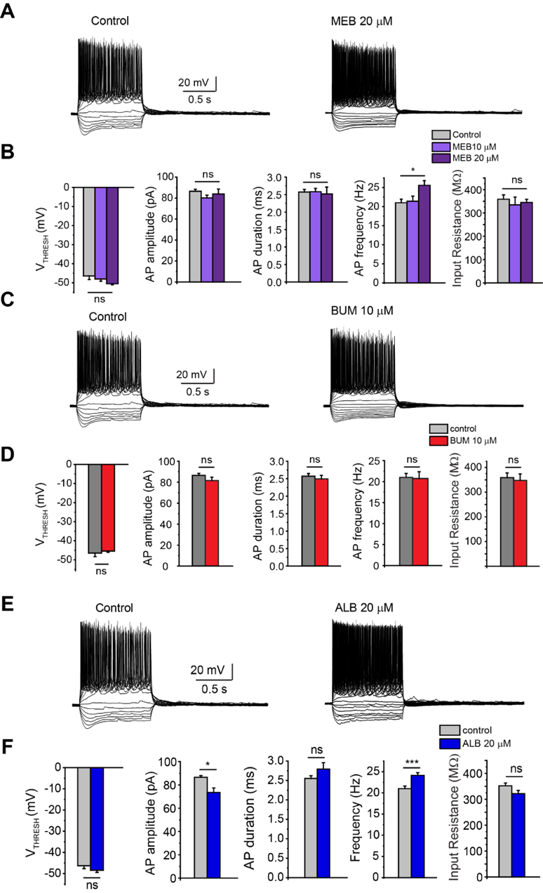
Figure 1. Mebendazole (A, B), bumetanide (C, D) and albendazole (E, F) do not significantly alter intrinsic properties of hippocampal CA1 neurons. B, D, F Quantitative measures. Action Potential (AP) amplitude, threshold (V_{Tresh}) and duration were not impacted by 10 or 20 µM MEB, like input resistance. AP frequency in response to +100 pA currents was slightly increased in the presence of mebendazole (B) and albendazole (F). The error bars represent SEM.
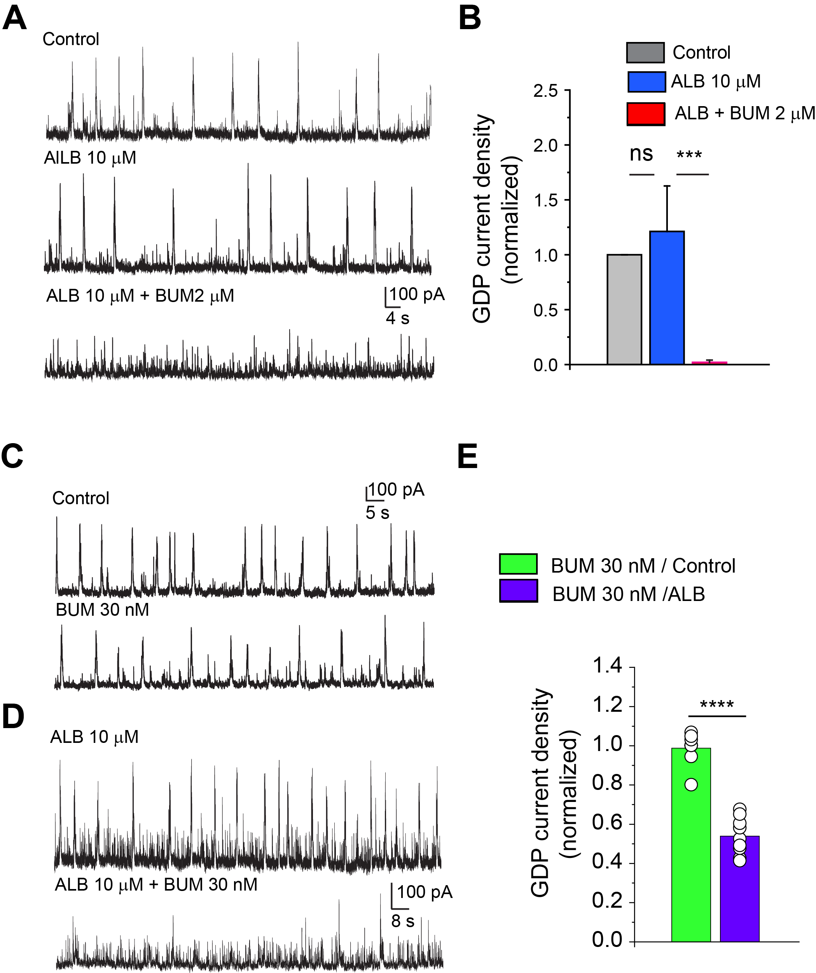
Figure 2. Albendazole enhances potency of GDP inhibition by bumetanide.
(A) Representative whole-cell patch-clamp recordings of GDP activity in CA3 pyramidal neuron in control conditions, 1 h after application of 10 µM of albendazole and in the presence of albendazole and bumetanide. Bumetanide (2 µM) blocks GDP activity in hippocampal slices treated with albendazole. (B) Quantification of the effects of albendazole and bumetanide (2 µM) on the GDP activity.
C-E Low concentration of bumetanide (30 nM) inhibits GDP activity in hippocampal slices treated with albendazole (D, E) but not in control (C, E). Representative whole-cell patch-clamp recordings of GDP activity in CA3 pyramidal neuron in control slices, in the presence of 30 nM of bumetanide, albendazole-treated slices and after co-application of albendazole and 30 nM of bumetanide. (E) Quantification of the effects of 30 nM of bumetanide on the GDP activity in control and albendazole-treated slices. Two-tailed two-samples t-test, p=4*e-8. The error bars represent SEM.
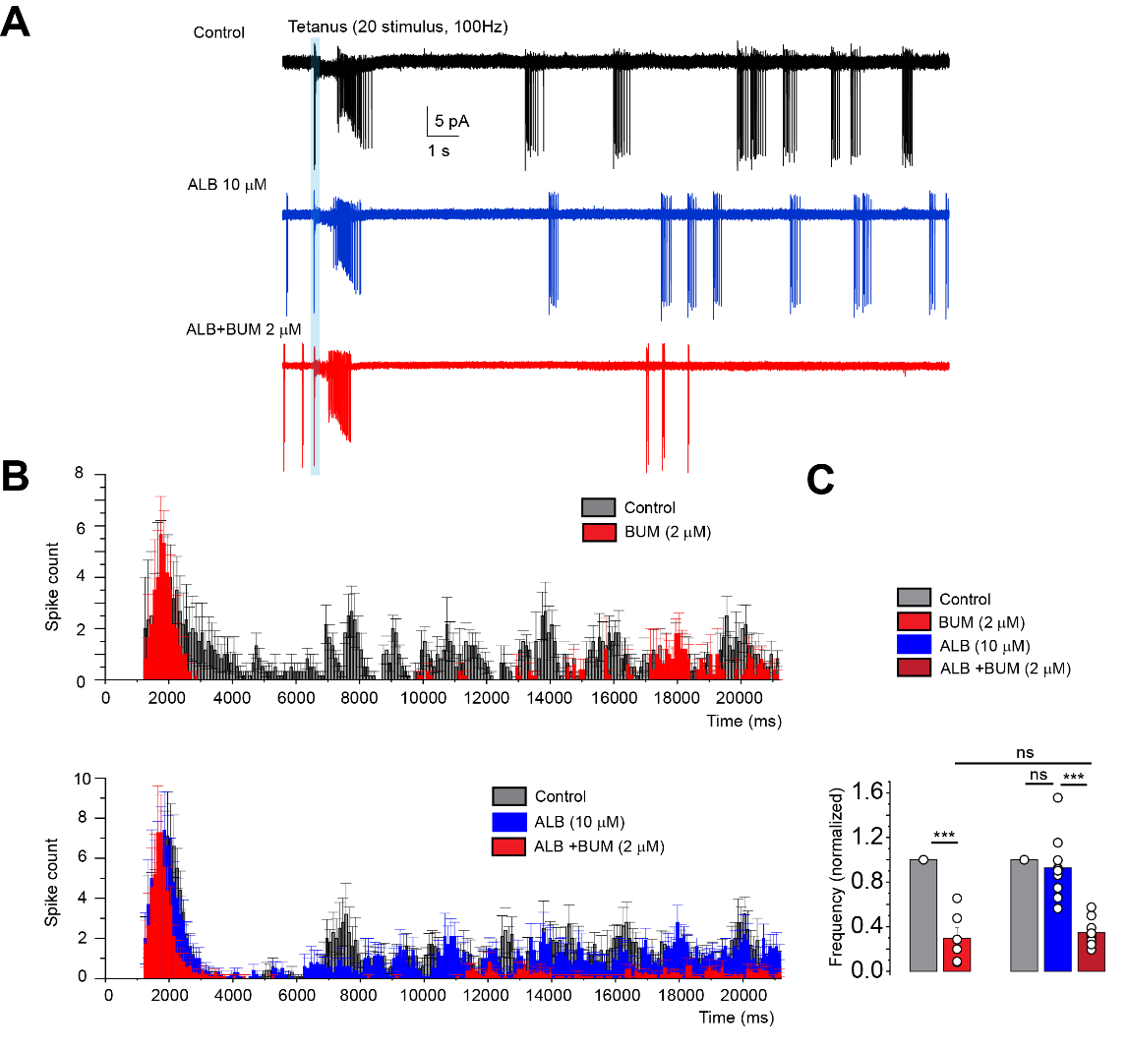
Figure 3. Bumetanide suppresses seizure-like events (SLE) triggered by tetanus stimulation in albendazole-treated hippocampal slices P 13-15.
(A) Representative, superimposed, cell-attached recordings in CA1 pyramidal neuron of SLE (4 consecutive traces are superimposed), induced by 100Hz stimulation (blue bar) of stratum radiatum in control conditions (black), after 1 h incubation with 10 µM of albendazole (blue) and 30 min after application of 2 µM of bumetanide (red). (B) Mean frequency histograms for the indicated conditions’, The summary of the effect of albendazole and bumetanide (2 µM) on post-tetanus spike frequency (withing 20 s window after tetanus stimulation). The error bars represent SEM.
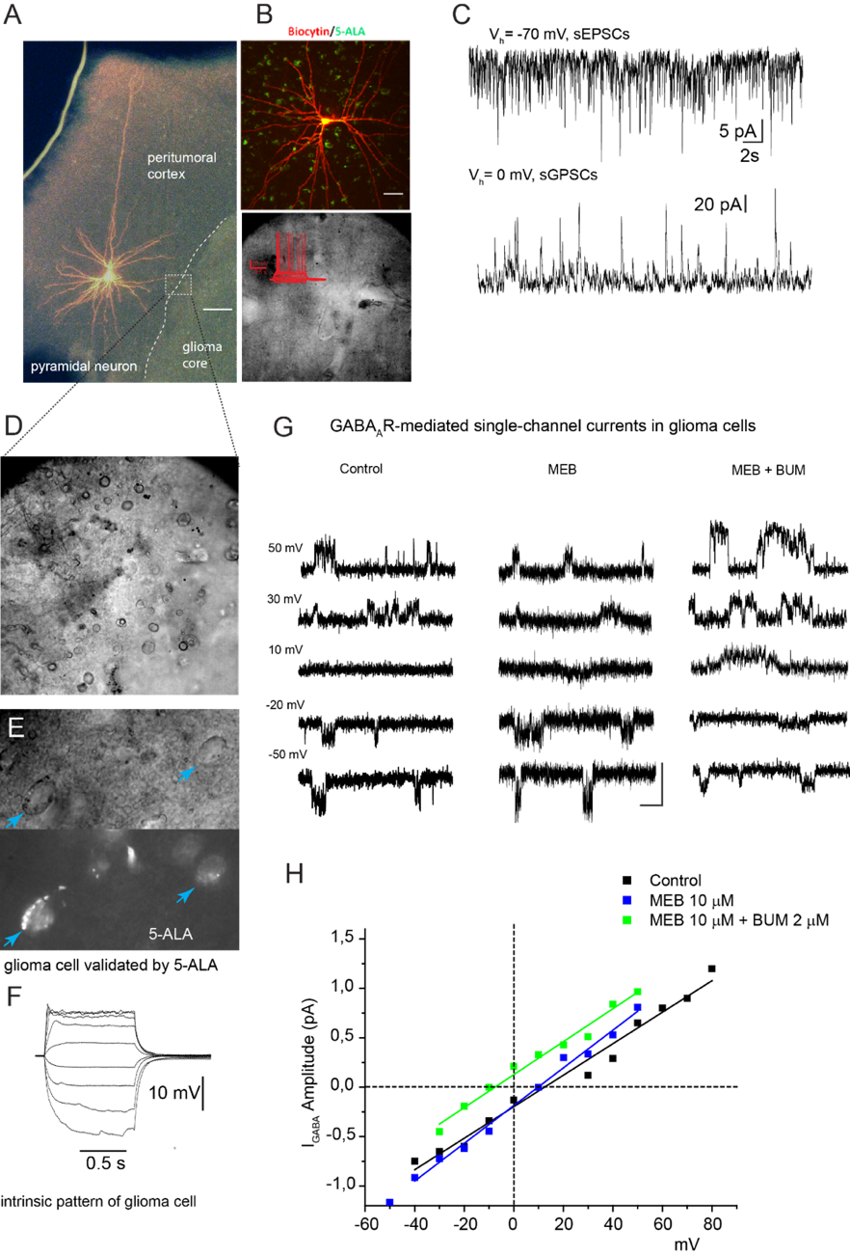
Figure 4. Mebendazole and bumetanide combo block the depolarizing driving force of GABA_{A}R-mediated currents in GBM cell.
(A) Experiment design: cortex/glioma interface in acute human brain slice with pyramidal neuron in peritumoral cortex. (B) Pyramidal neuron soma and basal dendrites at extended scale, Insert: Firing pattern of pyramidal neuron. (C) Spontaneous glutamatergic neuronal hyperactivity of pyramidal neuron in tumor adjacent cortex. Representative traces of whole-cell voltage clamp recordings of sEPSC at holding potential of −75 mV (upper trace) and sGPSC at 0 mV from individual pyramidal cell shown in A and B. (D-F) GBM neuron identified by 5-ALA staining and electrophysiological properties. (G) Representative recording GABA_{A}R-mediated single-channel currents at different holding potentials (scale bars mean 1 pA and 200 ms) in GBM cells in acute human slices in ACSF (control), mebendazole and mebendazole+ bumetanide. (H) Current-voltage (I-V) relations of GABA_{A}R single-channel currents in GBM cells in acute human slices in ACSF (black), mebendazole (10 µM, blue) or mebendazole+ bumetanide (2 µM, green). Bumetanide shifted DFGABA from depolarizing to hyperpolarizing potentials in GBM cells.
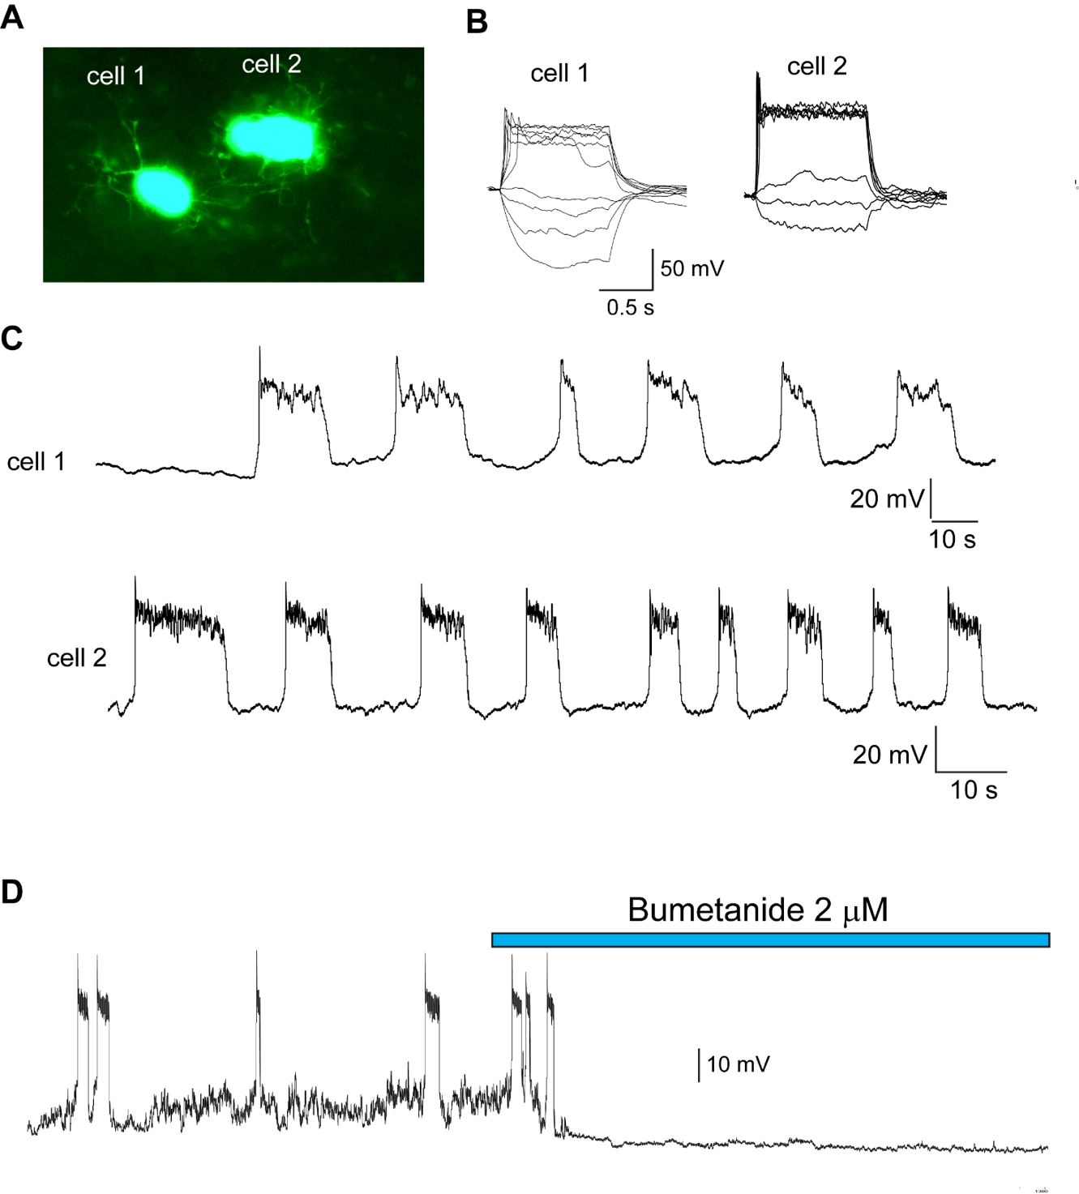
Figure 5. Pacemaker activity in tumor cells in oligodendroglioma (IDH-mutant) human acute slices. (A) Two tumor cells loaded with biocytin. (B) Representative traces of current -clamp patch-clamp responses of cell shown in A to the depolarizing current injections (increment 10 mV). (C) Representative traces of pacemaker activity in tumor cells recorded in current-clamp mode. (D) Bumetanide blocks spontaneous activity.
Figure 6. (A) A schematic representation of the production of human iPSC-derived neurospheres and the co-culture setting with GBM spheroids. (B) Representative pictures of Neuro^{Gfp}GBM^{mcherry/fLuc} co-cultured for 5 days. Zoom in and enhance the intensity of the fluorescence in both the green and red channels to show both neural infiltration and tumour invasion. (C) Gene expression analysis of genes involved in neural differentiation and stemness was conducted on neuro^{gfp} after 44 days of differentiation. D0 = hiPSCs. We used GAPDH expression as a housekeeping gene.
Figure 7. (A) The tumor area is analyzed on NeuroGfpGBMmcherry/fLuc cultures before treatment starts. There is no statistically significant difference between the groups. (B) The neurosphere area was calculated by analyzing NeuroGFPGBMmcherry/fLuc culture images on the GFP fluorescent channel before treatment start (T0) and 72 hours after treatment. (D) Percentage of neural dead cells was determined by DRAQ7 staining on GFP positive cells (neurosphere) after NeuroGFPGBMmcherry/fLuc culture dissociation, by FACS analysis. Bars are SEM. P-value= not significant (ns).

