Supplementary Table S1. Virulence genes elaborated by pathogenic E.coli and their functions.
Category | Gene | Role in virulence | Reference
Adhesins
Pathogenicity island | pai | Responsible for horizontal transfer of virulence genes | [6]
Type 1 fimbriae | fim ( fimA, fimF, fimG, fimH). | Colonization and biofilm formation | [7]
Afimbrial adhesin | Afa(afaA, afaE,  afaD, afaB , afaC) | Adherance to surface epithelium and Ability to induce hemagglutination | [7]
Nonfimbrial adhesin | nfaE | Functions as the periplasmic chaperone and as the molecular usher. Assembly and transport | [7]
Dr fimbriae | dra | Attachment and mediation of internalization of bacteria to the host cells | [7]
P fimbriae | papC, PapE | Stimulate production of cytokines by T lymphocytes, colonization | [7]
S fimbriae | sfa, | Adhesion to intestinal epithelial cells, kidney, lower urinary tract cells, facilitate the penetration of bacteria into the tissues | [7[
F1C fimbriae | foc | Adhesion to renal epithelial cells and endothelial cells of the bladder and kidneys | [7]
Attachment and Efacement | eaeA | Attachment and effacement factor | [7]
Mat | mat | Meningitis associated and temperature-regulated fimbriae | [7]
Curli fiber gene | crl, csg | Enable biofilm formation and promote pathogenicity | [7]
Antigen43 | agn43 | Protein of autotransporter family, adhesion and biofilm development | [7]
B. Invasins
Ibe ABC | ibe | Cell invasion of host tissues | [7]
C. Iron uptake
Aerobactin | iuc, aer, iutA | Siderophore, acquisition of Fe2+ / 3+ in the host system | [8]
Iron-regulated-gene | Iha  iha | Iron-regulated-gene-homolog adhesion | [8]
Iron repressible protein | irp | Yersiniabactin synthesis | [8]
Salmochelin | iroN | Siderophore receptor, use of Fe ions obtained from the body host | [8]
ChuA, Hma | chu, hma, fyuA | Enable using of Iron from hemoglobin in the host system | [8]
SitABC | sitA,B,C | Transportation of Iron and Manganese | [8]
D. Protectins/Serum resistance
Transfer protein | traT | Inhibition of the classical pathway of complement activity | [4]
Category | Gene | Role in virulence
E. Capsular antigens
Membrane capsule | KpsMI,  KpsMII | Protection factor against phagocytosis and the spreading  factor | [9]
 | rfc | O4 lipopolysaccharide synthesis | [9]
Outer membrane protein | ompA | Enable intracellular survival, evasion from the body’s defense. | [9]
Outer membrane protein | iss | Increased serum survival and protection factor against phagocytosis | [9]
Outer membrane protein | colV, cvaC | Factor facilitating colonization | [9]
F. Toxins
Heat stable toxin | Ethst (est) | Production of heat-stable enterotoxins (STs) | [4,10]
Heat label toxin | Ethlb (elt) | Production of heat-stable enterotoxins (STs) | [4,10]
Shigatoxen | Stx1  Stx2 | Production of exotoxins responsible for bloody diarrheal diseases that can progress to life-threatning systemic sequelae, such as hemolytic uremic syndrome (HUS) | [11]
Cytotoxic necrotizing factor | cnf1,  cnf2 | Engaging in cell necrosis | [12]
Cytolethal distending toxin | Cdt, cdt-B | Cytolethal distending factor | [12]
Secreted autotransporter toxin | sat | Proteolytic toxin, effect cytotoxic influences on cell vacuolization | [13]
Vacuolating autotransporter toxin | vat | Proteolytic toxin, induces host cell vacuolization | [14]
Hemolysin A | hlyA | Creation of pores in membranes of host cells (cell lysis) | [7]
G. Autotransporter
Serin protease autotransporter | pic | Degrades mucins, facilitates colonization of epithelium, damages of the cell membrane | [4]
Supplementary Table S2. Information on Primers and cycling conditions used in this study.
Genes | Primer Sequence (5’-3’) | cycling  (30cycles each) | Amplicon Size(bp) | Reference
16S rRNA : ECO-1  ECO-2 | gacctcggtttagttcacaga  cacacgtctgacgctgacca | 95 ºC/30s, 50 ºC/1 min,  72 ºC/1 min | 585 | [29]
pai : pai-F  pai-R | ggacatcctgttacagcgcgca  tcgccaccaatcacagccgaac | 95 ºC/30s, 56 ºC/1 min,  72 ºC/1 min | 930 | [29]
fimH: fimH-F  fimH-R | tgcagaacggataagccgtgg  gcaagtcacctgccctccggta | 95 ºC/1 min, 55ºC/1 min,  68 ºC/1 min | 508 | [3]
afa : afa-F  afa-R | ggcagagggccggcaacaggc  cccgtaacgcgccagcatctc | 95 ºC/1 min, 58 ºC/1 min,  68 ºC/1 min | 559 | [3]
nfaE: nfaE-F  nfaE-R | gcttactgattctgggatgga  cggtggccgagtcatatgcca | 95 ºC/1 min, 55 ºC/1 min,  68 ºC/1 min | 559 | [3]
papC: papC-F  papC-R | gacggctgtagtgcagggtgtgcg  atatcctttctgcagggatgcaata | 95 ºC/1 min, 52 ºC/1 min,  68 ºC/1 min | 328 | [30]
papE: PapE-F  PapE-R | gcaacagcaacgtggttgcatcat  agagagagccactcttatacggaca | 95 ºC/1 min, 55 ºC/1 min,  68 ºC/1 min | 336 | [3]
bmaE: bmaE-F  bmaE-R | atggcgctaacttgccatgctg  agggggacatatagcccccttc | 95 ºC/1 min, 54 ºC/1 min,  68 ºC/1 min | 507 | [3]
cvaC: ColV-C-F  ColV-C-R | cacacacaaacgggagctgtt  cttcccgcagcatagttccat | 95 ºC/1 min, 52 ºC/1 min,  68 ºC/1 min | 680 | [3]
kpsMTII: kpsII-F  kpsII-R | gcgcatttgctgatactgttg  catccagacgataagcatgagca | 95 ºC/1 min, 50 ºC/1 min,  68 ºC/1 min | 392 | [31]
rfc: rfc-F  rfc-R | atccatcaggaggggactgga  aaccataccaaccaatgcgag | 95 ºC/1 min, 52 ºC/1 min,  68 ºC/1 min | 788 | [31]
iutA: AerJ-F  AerJ-R | ggctggacatcatgggaactgg  cgtcgggaacgggtagaatcg | 95 ºC/1 min, 56 ºC/1 min,  68 ºC/1 min | 300 | [3]
IRE: Ire-F  Ire-R | gatgactcagccacgggtaa  ccaggactcacctcacgaat | 95 ºC/1 min, 52 ºC/1 min,  68 ºC/1 min | 254 | [32]

Multiplex 1
ChuA: ChuA-F  Chua-R | atggtaccggacgaaccaac  tgccgccagtaccaaagaca | 95 ºC/10min  68 ºC/10min | 279 | [3]
ibeA: ibe10-F  ibe10-R | aggcaggtgtgcgccgcgtac  tggtgctccggcaaaccatgc | 95 ºC/10min  68 ºC/10min | 170 | [3]
hlyA: hlyA-F  hlyA-R | gcatcatcaagcgtacgttcc  aatgagccaagctggttaagct | 95 ºC/10min  68 ºC/10min | 534 | [33]

Multiplex 2
Ethst(est): est-F  est-R | tctgtattgtctttttcacctttc  ttaatagcacccggtacaagc | 95 ºC/10min  68 ºC/10min | 165 | [34]
Ethlb(elt): elt-F  est-R | atgagtacttcgatagagg  atggtattccacctaacgc | 95 ºC/10min  68 ºC/10min | 279 | [35]
cnf1: cnf1-F  cnf2-R | aagatggagtttcctatgcaggag  cattcagagtcctgccctcattatt | 95 ºC/10min  68 ºC/10min | 498 | [36]
Stx (1): stx1-F  stx1-R | ataaatcgccattcgttgactac  agaacgcccactgagatcatc | 95 ºC/10min  68 ºC/10min | 180 | [36]
Stx (2): stx2-F  Stx2-R | ggcactgtcgaaactgctcc  tcgccagttatctgacattctg | 95 ºC/10min  68 ºC/10min | 255 | [36]
Cdt: cdt-a1-F  cdt-a2-R | aaatcaccaagaatcatccagtta  aaatctcctgcaatcatccagttta | 95 ºC/10min  68 ºC/10min | 430 | [37]
eaeA; eaeA-F  eaeA-R | tgcggcacaacaggcggcga  cggtcgccgcaccaggattc | 95 ºC/10min  68 ºC/10min | 384 | [36]
Supplementary Table S3. Virulence genes profile.
Gene | Number of isolates with virulence gene | % among isolates | % among virulence genes | Class of virulence genes | Number of isolates with virulence genes | % among isolates | % among virulence genes
FimH | 44 | 18.0 | 24.7 | Adhesins | 81 | 33.2 | 45.5
papC | 15 | 6.1 | 8.4
papE | 4 | 1.6 | 2.2
afa | 12 | 4.9 | 6.7
bmaE | 6 | 2.5 | 3.4
nfaE | 0 | 0.0 | 0.0
KSP11 | 13 | 5.3 | 7.3 | capsule synthesis | 13 | 5.3 | 7.3
rfc | 0 | 0.0 | 0.0
ibeA | 3 | 1.2 | 1.7 | Invasins | 13 | 5.3 | 7.3
cvaC(COLV) | 10 | 4.1 | 5.6
cnf1 | 8 | 3.3 | 4.5 | Toxins | 33 | 13.5 | 18.5
cdtB | 3 | 1.2 | 1.7
STX1 | 2 | 0.8 | 1.1
STX2 | 13 | 5.3 | 7.3
eltA | 2 | 0.8 | 1.1
estII | 5 | 2.0 | 2.8
iutA | 12 | 4.9 | 6.7 | Siderophores | 26 | 10.7 | 14.6
ire | 3 | 1.2 | 1.7
chuA | 11 | 4.5 | 6.2
aeA | 0 | 0.0 | 0.0 | Other virulence genes | 12 | 4.9 | 6.7
PAI | 2 | 0.8 | 1.1
hlyA | 10 | 4.1 | 5.6
TOTAL | 178 | 73.0 | 100.0 | TOTAL | 178 | 73.0 | 100.0
Supplementary Table S4. Antibiotic susceptibility patterns of the 50 E. coli isolates from stool samples.
Antibiotic | Sensitive n (%) | Intermediate n (%) | Resistant n (%) | X2 | P value
AMX | 2(4) | 3(6) | 45(90) | 72.28 | 0.000
AM | 5(10) | 0 | 45(90) | 32.0 | 0.000
CRO | 24(48) | 9(18) | 17(34) | 6.76 | 0.034
C | 18(36) | 0 | 32(64) | 3.92 | 0.047
CIP | 37(74) | 1(2) | 12(24) | 40.84 | 0.000
NOR | 15(30) | 3(6) | 32(64) | 25.58 | 0.000
DO | 10(20) | 3(6) | 37(74) | 38.68 | 0.000
TE | 9(18) | 1(2) | 40(80) | 50.92 | 0.000
CN | 38(76) | 2(4) | 10(20) | 42.88 | 0.000
K | 5(10) | 13(26) | 32(64) | 23.08 | 0.000
SPT | 7(14) | 6(12) | 37(74) | 37.24 | 0.000
S | 12(24) | 2(4) | 36(72) | 36.64 | 0.000
MET | 0 | 0 | 50(100) | 0.000 | 1.000
SXT | 3(6) | 3(6) | 44(88) | 67.23 | 0.000
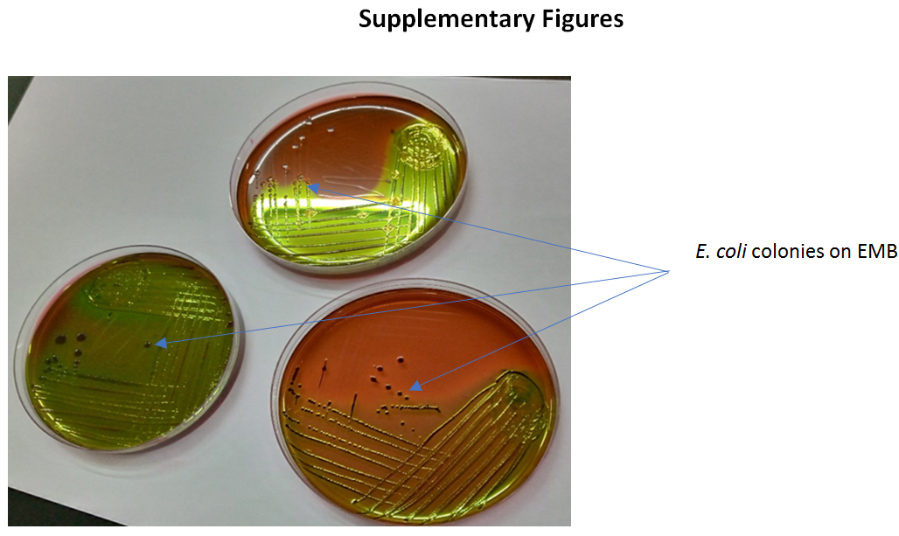
Figure S1. Growth of typical green metallic sheen colonies of E.coli on EMB.
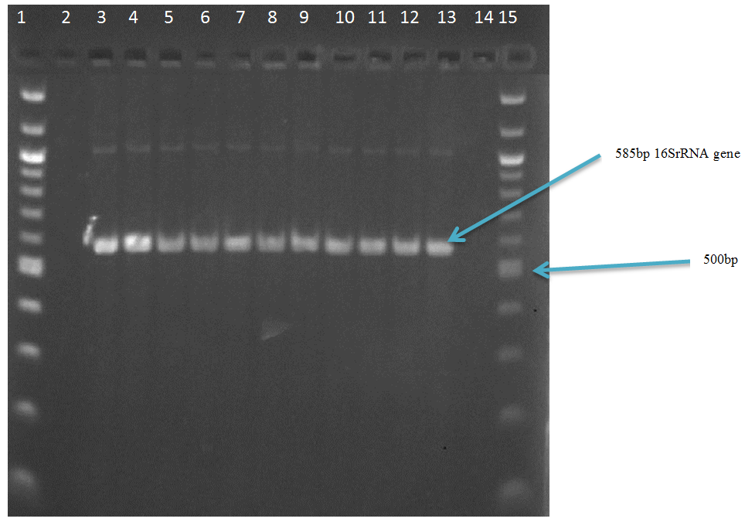
Figure S2. Electrophoretic separation of PCR products of 16S rRNA gene on 1.5 % agarose gel. Lane 1and 15;100 bp molecular marker (ladder), Lane 2; negative control; Lane 3-13; positive samples(expected band sizes at 85bp). and Lane14;Negative sample.
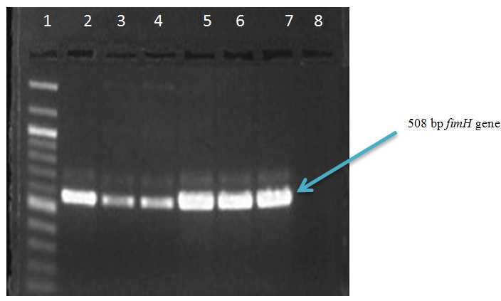
Figure S3. Electrophoretic separation of PCR products of fimH gene on 1.5 % agarose gel. Lane 1, 100 bp molecular marker (ladder);Lane 2-7, positive samples; Lane 8, negative samples.
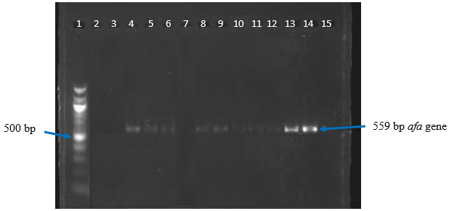
1 2 3 4 5 6 7 8 9 10
Figure S4. Electrophoretic separation of PCR products of afa gene on 1.5 % agarose gel. Lane 1, 100 bp molecular marker (ladder); Lane 2, negative control; Lane 4,5,6,8 and 9-14 positive samples; Lane 3,7, and 15, negative samples.
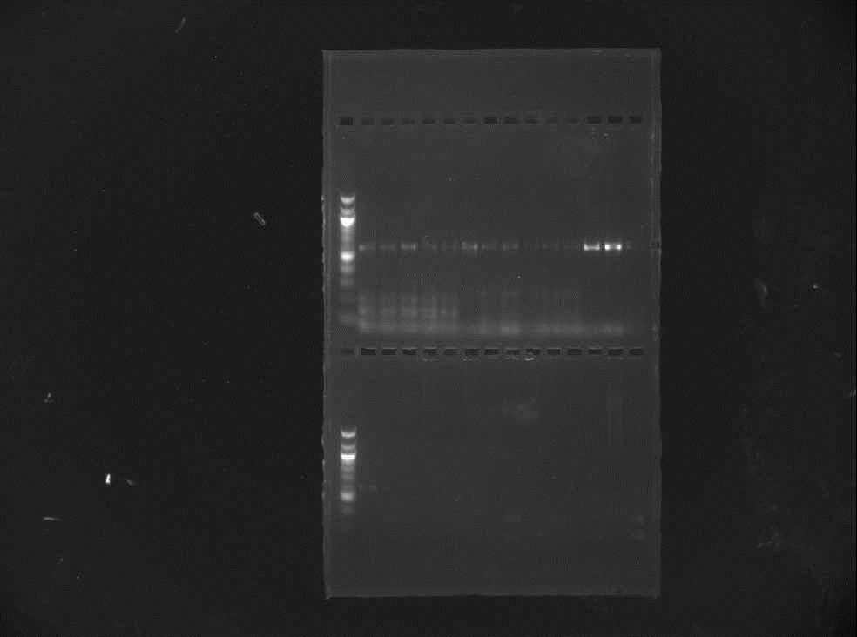
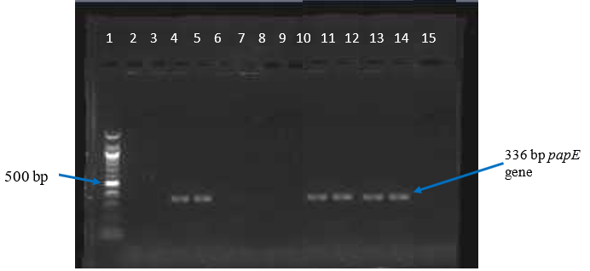
1 2 3 4 5 6 7 8 9 10 12 13 14 15
Figure S5. Electrophoretic separation of PCR products of papE gene on 1.5 % agarose gel. Lane 1, 100 bp molecular marker (ladder); Lane 2, negative control; Lane 4, 5, and 10-14, positive samples; Lane 3, 6-9, and15, negative samples.
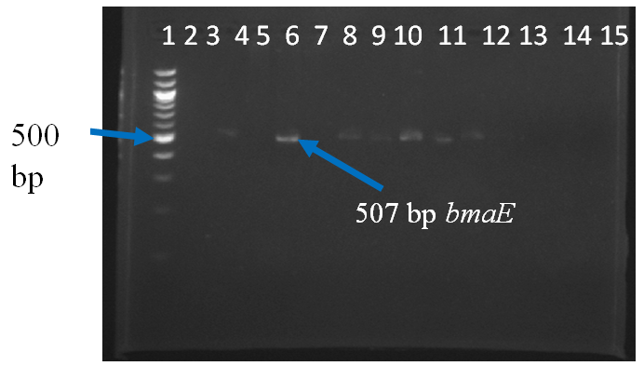
Figure S6. Electrophoretic separation of PCR products of bmaE gene on 1.5 % agarose gel. Lane 1, 100 bp molecular marker (ladder); Lane 2, negative control; Lane 3,5,7-11 positive samples; Lane 4,6 and 12-15, negative samples.
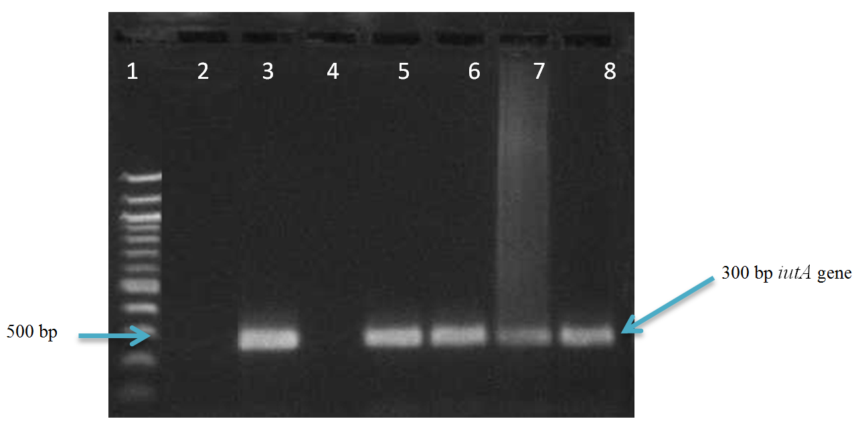
Figure S7. Electrophoretic separation of PCR products of iutA gene on 1.5 % agarose gel. Lane 1, 100 bp molecular marker (ladder); Lane 2, negative control; Lane 3,5,6,7,and 8 positive samples; Lane 4, negative samples.
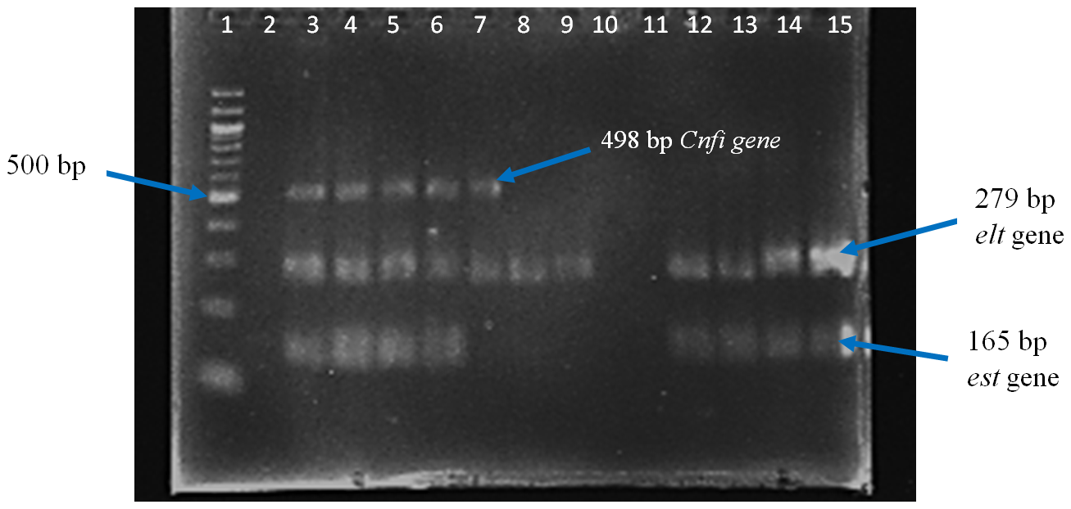
Figure S8. Electrophoretic separation of PCR multiplex products of est, elt and Cnfi genes on 1.5 % agarose gel. Lane 1, 100 bp molecular marker (ladder); Lane 2, negative control; Lane 3-6, positive samples possessing the three genes; Lane 7, sample containing the Cnfi gene and the elt gene; Lane 8 and 9, positive samples for elt gene only; Lane 12-15, positive samples for elt and est genes; Lane 10 and 11, negative samples.

