Lecture and Teacher Notes

Automation of the Ad Hoc Approach for Derandomization of Proteins: A Tutorial for Undergraduates in Molecular Sciences
Adewale Olamoyesan^{1,2,3} *
¹Department of Molecular Sciences, Macquarie University, Sydney, Australia
²Department of Chemistry, University of Lagos, Lagos, Nigeria
³College of Science and Computing, Wigwe University, Isiokpo, Nigeria

Corresponding author: Adewale Olamoyesan
Email addresses: adewale.olamoyesan@hdr.mq.edu.au; adewale.olamoyesan@unilag.edu.ng

TABLE OF CONTENTS
s1: Lecture Note…………………………………………………………………………………….1
s2: Teacher Note...………………………………………………………………………………… 28
S1 LECTURE NOTE
Circular Dichroism
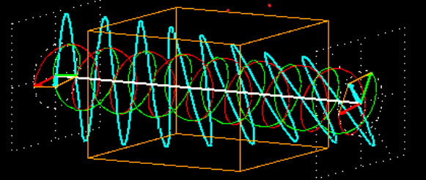

Circular dichroism, CD is an alternate form of linear dichroism spectroscopy that uses circularly polarized light to analyse important biomolecules such as proteins, nucleic acids and DNAs. The commonly derived information using this technique for proteins are :
- the secondary structure adopted and conformation change in different conditions.
- the protein stability through thermal melting and denaturation studies.
The term ‘dichroism’ in this spectroscopy type name is derived from the Greek word ‘ιϰρѡμα’, which implicitly describes the different extent of absorption of two opposing polarized lights by a sample .

Models Used to Describe CD
CD is defined as the differential absorption between circularly polarized lights, one to the right and the other to the left.
This relationship is described by the expression:
$CD=∆A=A_{L}-A_{R}$………………….1
In terms of extinction coefficient equation 1 can be expressed as:
$∆ε=ε_{L}- ε_{R}= \frac{∆A}{cl}$…………………..2
Where,
$∆A$ is the difference in the light absorbed by the chiral molecule,
$ε_{L}$ and $ε_{R}$ are the molar extinction coefficient of left and right circularly polarized light,
c is the concentration of the chiral molecule in solution measured in mol.l^{–1},
$l$ is the cell pathlength.

Note: ∆ is typically < 10 M^{¬1}cm^{¬1} but must not be equal to zero.

CD Units and Inter-Convention
∆A or $∆ε$ , is usually plotted against the wavelength $⋋$ to generate a report in the form of a CD spectrum. The CD report from most spectrophotometers is in millidegrees, which can be easily converted into molar extinction coefficient, $∆ε$ units and other units such as molar ellipticity using the relationship in the table below:
Table S1. Conversion of CD absorbance from one units to another units
From/To (units) | Absorbance, A | Molar extinction,  | Millidegrees, m○ | Molar Ellipticity, []
Absorbance, A (Abs) |  | A*M/C*L | A*32980 | A*M*32980/C*L
Molar extinction,  (M⁻¹cm⁻¹) | *C*L/M |  | *C*L*32980/M | *32980
Millidegrees, m○(mdeg) | m○/32980 | m○M/(C*L*32980) |  | m○M/(10*C*L)
Molar Ellipticity, [] (deg×cm²/dmol.) | []*C*L/(3298*M) | []/3298 | []*C*L*10/M

- Molar absorptivity normalizes the CD spectra based on concentration (in mol/L), and pathlength (in cm).
- Ellipticity (θ), is related to absorbance by a factor of 32.98 (θ = 32.98 ΔAbs) which is usually reported in millidegrees.

- To convert from absorbance to molar ellipticity the CD is corrected for concentration and scaled by a thousand of the factor used for ellipticity (3298).
- For the protein sample, the mean residual weight (M) is used in place of the molecular weight, essentially treating the protein as a solution of amino acids.
Note: There is an optimum absorbance to use (Abs = 0.89). For a 1 mm pathlength cell, this absorbance is achieved with a protein concentration of about 0.1-0.3 mg/mL
CD Spectra for Different Secondary Structures

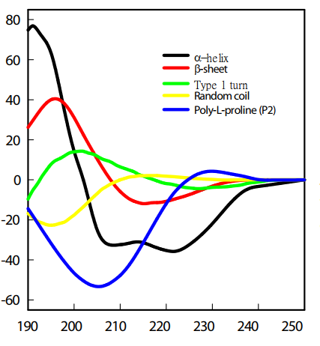
Wavelength, nm
[] X10⁻³, deg.cm².dmol⁻¹

Figure S1. The spectra for standard proteins with predominant each structure type.

Table S2. The features displayed by structure types generally found in typical proteins and the corresponding electronic transition for each of the peaks
Structure  Type/  Peak sign | α-helix |  | β-sheets |  | β -turns |  |  | Random
Structure  Type/  Peak sign | Position  (nm) | E transition | Position  (nm) | E transition |  | Position  (nm) | E transition |  | Position  (nm) | E transition
Positive | 190-192 | $$π_{nb}→ π^{*}$$ | 195-202 | $$π→ π^{*}$$ |  | 200-205 | $$π→ π*$$ |  | Ca. 218 | $$n→ π^{*}$$
Negative | 208 ; 222 | n$→$ $π^{*}$; n$→$ $π^{*}$ | 215-219 | $$n→ π^{*}$$ |  | 180-190; 225 | $$π→ π*; n→ π^{*}$$ |  | 195-200 | $$π→ π^{*}$$

Note: The three of five orbitals responsible for the electronic transitions of all the secondary structures of proteins are non-bonding orbital, π_{nb}; oxygen lone pair orbitals, n and n’; anti-bonding oribital, $π^{*}$ bonding, $π$.

How are CD Signals Produce?
Typically, most spectrophotometers have similar components like light source, prisms, silts, mirrors, and detector. CD machine has among those a photoelastic modulator, PEM and a photomultiplier tube, PMT. The optics for a typical CD spectrophotometer is shown in Figure S2. The light source is mostly a Xenon arc lamp for measurements in the UV and visible regions of the electromagnetic wave. PEM is an extremely important component of the machine, which comprises crystalline quartz coupled with silica quartz. Light passes through the silica section while to the crystalline section alternate current is applied. This causes the crystalline quartz to oscillate at 50 Hz and silica to be birefringent consequently turning it into a dynamic quarter-wave plate. Tuning the amplitude of oscillation of the quarter-wave causes it to select only the horizontal components of the polarized light to turn to circularly polarized light. Then, the light produced passes through the sample in its compartment and the PMT transforms not absorbed light to electrical signal. The nature of the current observed by this detector indicates if the sample has a CD or not.
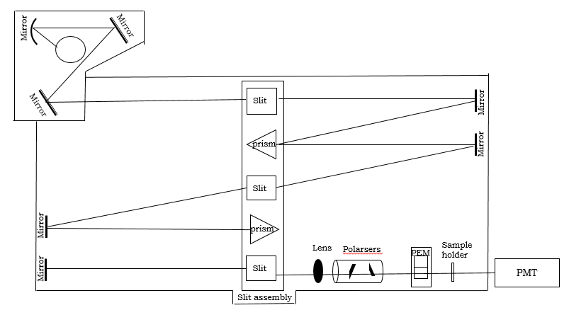
Figure S2. Diagram of the common optics (elements) that constitute a CD machine and the arrangement of these elements.
For instance, PMT shows varied current (AC) resulting from the chirality of the sample or induced by the environment. CD signal is computed from the ratio of the currents detected (when the sample has CD to otherwise), whose sign is derived from the phase of the AC by a lock-in amplifier that uses the AC voltage of the PEM to reference the DC.
$CD={<AC>}/{DC}$…………………………………………………........3
Table S3. Common Optics in Spectrophotometer and their Functions
Component | Function
Light source | Used to produce light of specific wave spectrum.
Mirror | To reflect or refract light received from light source or other components.
Slit | It determines the amount of light allow to enter the spectrophotometer for processing. This optic’s width is one of important parameters used to determine the resolution of spectrophotometer.
Prism | Selects the relevant wavelength by analyzing light.
Lens | Collects radiation from silt or other components or source to direct to other components.
Polariser | Used to filter light of mixed polarization by allowing specific polarization to pass through it.
Sample holder | Cuvettes or quartz are used to hold the sample for spectroscopy analysis.

How are the Proportions of Structures in Proteins Determined?
CD practitioners can give a qualitative analysis of the structures present, but cannot say precisely how much of each type of structure is present. A number of programs have been developed for this purpose based on statistical and intelligent systems such as:
- LINCOMB (The least squares)
- CONTIN (The ridge regression procedure)
- VARSLC (The variable selection method)
- SELCON (The self-consistent method)
- K2D, SSNN or SOMSpec (A neural network)
- CCA (The convex constraint algorithm)
- SVD (singular value decomposition)

The intelligent system of much relevance to this work is the self-organizing map, SOM which our SOMSpec (self-organizing map spectroscopy, a program for secondary structure analysis of protein spectra) is based on. SOMSpec was used by both the instructors and students to determine the exact proportions of structure in the derandomised protein or otherwise.

Advantages and Disadvantages of CD

Advantages
- Simple and quick experiments. No extensive preparation.
- Measurements on solution phase.
- Relatively low concentrations/amounts of sample.
Disadvantages
- Difficult to quantitate similarity or difference.
- Certain buffer components absorb strongly in far UV and can cause interference.

Self-organizing Map
- Self-organising map, SOM, is a type of artificial neural network (ANN) developed by Finnish professor Teuvo Kohonen, also known as a self-organising feature map (SOFM), or Kohonen Map.
- SOMs do learn on their own without any supervision to form classifications of training data (the nodes are self-organising through competitive learning).
- SOMs are shallow ANNs that, in most applications consist of a single-layer rectangular 2-D grid of neurons as output layer.
- The map typically acts as a projection for derived low-dimensional data from its high-dimensional counterparts.
Representation of a SOM
- Each node represent an input vector
- Assignment of nodes is completed by the time training has finished.

SOM Training Methodology
The BMU (cream circle)
BMU neighbourhood (purple)
The rest (blue circles) are not updated by this iteration.

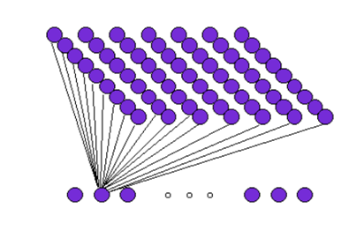
(b)
(a)
Each output node is a vector of n weights
Input layer— each node is a vector representing N terms
Kohonen layer
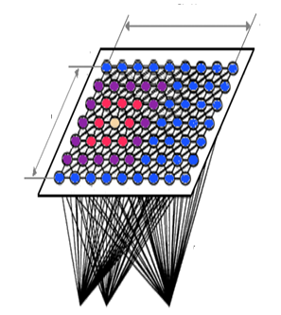
X₁ X₂……..X_{n}
Input vector
Size Y
W_{ij}
Size Y
Size X
W_{ij}

Figure S3. Schematic representation of a (a) SOM and its (b) training methodology
How Does SOM Work?
- Initialize the weighing vector with the same dimensionality, attribute definition(s) and sequence as the input vector is expressed below:
W = ($w_{i1}+ w_{i2},…,w_{id}$), where i or j =1, 2..., m………………………………....3
m denotes the number of all nodes in the map, i and j are unit vectors respectively along the x- and y-axis in vector space (this is the familiar (x, y) plane).
- Iterate the steps below for n times or until its converge:
  - Select an input vector out of the input vectors to predict features.
    - Determine the nodes very similar to the input vector using discriminating factor (Euclidean distance).
$d_{ij}=\sum_{ij=1}^{m}{{\left(x_{ij}(t)-w_{ij}^{'}(t)\right)}^{2}}$……………………………………………..4
    - Update the winner node’s neighbourhood nodes and the winner.
$w_{i}\left(t +1\right)=w_{i}\left(t\right)+ θ(t)L(t)\left(I\left(t\right)-w_{i} (t)\right)$ ………………………………..5
  - Calculate the learning rate.
  - Calculate the neighbourhood function of the winner node.
Note:
- To evaluate the secondary structure from CD spectra of proteins or peptides. The spectra for proteins with known structures are used as training sets to produce SOM, and the derived map is applied to estimate the content of structure types in the unknown proteins.
- The optimum iteration is between 20,000 – 50,000 taking into consideration other important parameters that would impact the prediction quality and its reliability.
SOMSpec
SOMSpec is a utility for predicting the secondary structure of unknown proteins or peptides with spectra collected using either circular dichroism (CD) or infrared (IR) or Raman spectrophotometer. This is implemented through unsupervised learning a form of neural network known as a self-organizing map, SOM, of which SOMSpec derived its name from the acronyms for self-organizing and spectroscopy.
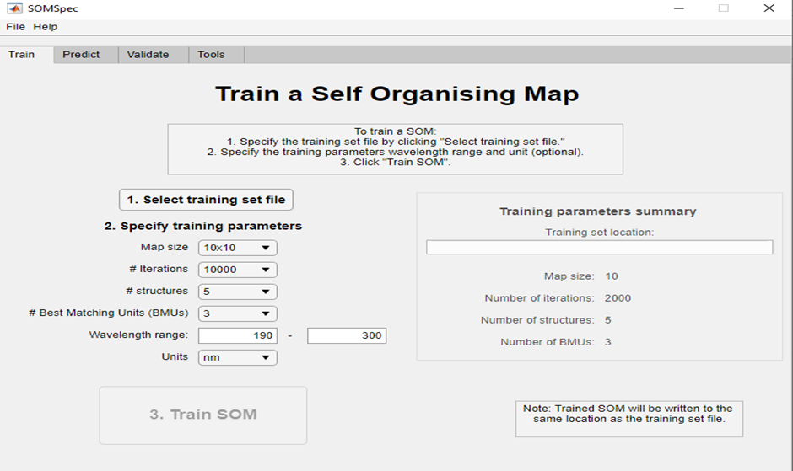
Figure S4. SOMSpec user interface designed to train SOM using spectra of proteins with known structures.

Proteins
Proteins are biological systems that play key roles in the cells of living organisms like transporting molecules, and controlling of synthesis of hormones and enzymes. The characteristic structures adopted are important to their functions and stability in cells, as this provides insight into their biological properties and effects in any state. There are thousands of different proteins in each cell in the living system, each with a special function. These molecules exist in different sizes that range from 50 to 33,423 amino acids, while macromolecules built with amino acids below the lower bound of proteins are called peptides.

Table S4. Notable examples of proteins
Protein | Description
Insulin | First completely sequenced protein
Myoglobin | First crystallized protein structure
Ribonuclease | Denatured protein that spontaneously refolds and regains enzymatic activity
TRP-cage | Smallest protein, containing 50 amino acids
Titin | Largest protein, containing 33,423 amino acids

Protein Structure
Protein structure is usually divided into four different levels that reflect the order of complexity of the structure namely primary, secondary, tertiary, and quaternary structure.
- Primary structure consists of sequence of amino acids arranged in a one-dimensional linear chain that subsequently folds into a compact globular structure (secondary structure).
- The tertiary structure results from secondary structure units held together by different forces of attraction like hydrogen bonds and van der Waals forces which enable them to fold into a three-dimensional (3-D) conformation.
- The quaternary structure is the highest organisation of more than one polypeptide chain or subunit into complexes. It is made up of some number of tertiary protein structures that interact as subunits serving multiple functions.

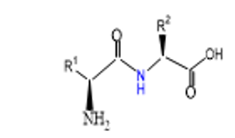  (a) | 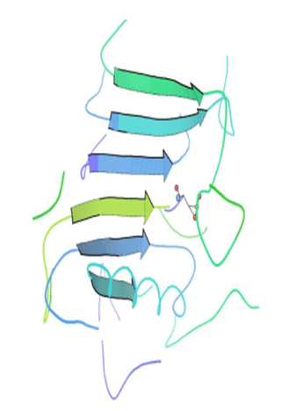  (b) | 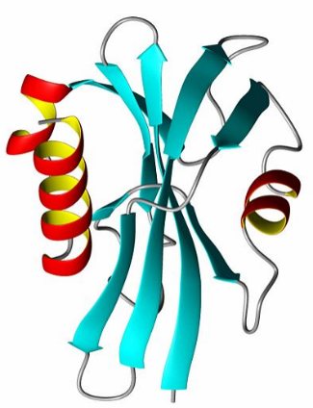  (c) | 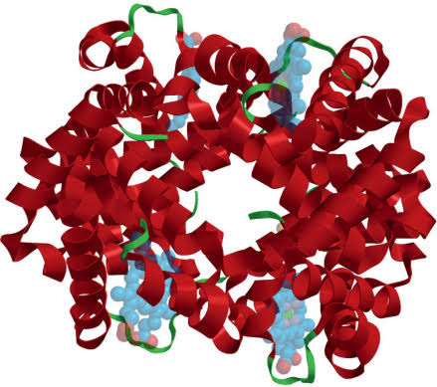  (d)

Figure S5. The protein structures according to their level of complexity from 1-D to 3-D (a) primary structure (amino acid sequence), (b) secondary structure (parallel β-sheet), (c) tertiary structure (P13 protein), (d) quaternary structure (haemoglobin).

Table S5. Description of secondary structure types and their respective molecular shapes
Conformation | Structure Model | Description
Alpha helices | 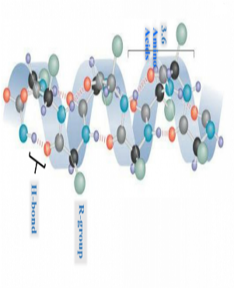 | In α-helices the backbone chain of a protein twists around itself with a pitch of 5.4 Å, and on average 10 amino acid residues are expected per helix. They are the most notable structural element in a protein. Examples of proteins that consist predominantly of this structure type are the first two structures determined, myoglobin and haemoglobin, transmembrane domains, α- keratins (makes up significant component of hair, skin, etc.).
Beta sheet | 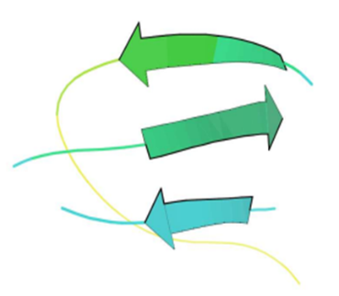 | β-sheets are nearly fully extended portion of the polypeptide chains. The backbone of such motifs is arranged in a zigzag with 120º angles. β-strands self-assemble into β-sheets via hydrogen bonding with at least two amino residues, forming twisted (right-handed fashion) and pleated sheets. As the second most common and folded structure element in protein to be discovered after a year of discovery of α-helix. This structure type was first found in fibroin, which is the predominant constituent of silk. Another examples of protein whose structure type is predominantly β-sheet protein is β-Lactoglobulin.
Turns | 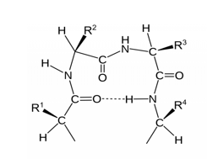 | About 35% of residues in typical proteins are turns. They are responsible for reversing the direction of the polypeptide chain within a globular protein, and are known to be the connector for other elements.
Random coils | 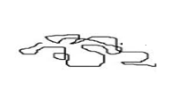 | Is the label used to describe protein structural elements that are devoid of any regular structure, they are not associated with any distinctive or regular hydrogen bonding patterns. They are flexible linkers and hinges. Most folded structures are reduced in entirety to unstructured form under one of the strongest basic denaturants as such guanidinium chloride GdnHCl.

Derandomized Proteins
Protein with suspected significant unfolded domains systematically removed from its core in solution is referred to derandomized protein using the mathematical model below.
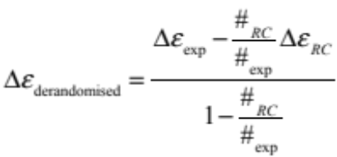 ……………………6
Where 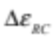 is the CD spectrum of the RC SufI-KK peptide MSLSKKQFIQASGIALCAGAVPLKASA (is a variant of Sufl—an example of a typical E. coli Tat substrate. Synthesized with a typical RR-signal peptide of which the twin-arginine motif is substituted with twin-lysine), # denotes number of residues, and exp denotes the full protein on which data were collected.

How to Prepare Protein Solution for CD?
- Phosphate Buffered Saline, pH 7.4
- Dissolve 8.7 g NaCl, 1.82 g K₂HPO₄ v3H₂O, and 0.23 g KH₂PO₄ in 1 L of distilled water.
- Adjust the pH to 7.4 before use.
- Protein stock solution
- Dissolve protein in buffer solution to give a protein solution of a concentration 10 mg/mL.
- Protein sample for CD
- Buffer exchange the protein to distilled water by using Amicon 0.5 mL centrifugal filters.
- Further dilute in distilled water to a final concentration of 0.1 mg/mL.
- Determine the actual concentration by absorbance spectroscopy using Beer’s lambert law. For example, using the published extinction coefficient of lysozyme to be 38940 cm⁻¹M⁻¹ at 280 nm, absorbance (Abs) at 280 nm, and pathlength of cuvette (0.1 mm) used for the absorbance measurement (UV).

Note: the published molar extinction for insulin is 5.8X10⁻³ cm⁻¹M⁻¹ at 280 nm.

Absorption Spectroscopy
UV Measurements Using JASCO Spectrometer
Note: | - Do not wear gloves to touch switches, keyboard or mouse.
Note: | - Ensure the cuvette is not filled to brim or less than ¾ full with protein solution of 300 μL for CD spectra collection.

Procedure

- Turn on the spectrophotometer, and other components (computer …and monitor). The lamp takes around 20 minutes to warm up.
- To measure a spectrum, open the sample compartment. Place the cuvette in the sample compartment. Ensure the appropriate side (not the grooved) faces the light. Purge the sample chamber with nitrogen.
- Launch the spectrophotometer software by clicking the Jasco V-760 icon on the desktop. Select the Spectrum Manager program and open Spectrum Measurement.
- To program each spectrum, go to measurement > parameter. When this IS completed. Click on “Data file” to save the spectra in a folder of your choice. Click “Save”.
- Take a reading of the blank (buffer) by scanning through 200 nm to 800 nm. The instrument store this data to perform baseline correction.
- Take reading of the samples. When the data collection is complete. You can copy the saved spectrum from the specified folder.

CD Measurements Using JASCO Spectrometer
Note: | - Do not wear gloves to touch switches, keyboard or mouse.
Note: | - Ensure the 0.1 mm pathlength quartz cell is filled with protein solution of 300 μL for CD spectra collection.

Procedure

- Turn on black power switch located on left-hand side of instrument. The lamp takes at least 10 minutes to warm up.
- Turn on computer and launch SpectraManager 2 software. Wait until purging is complete.
- To measure a spectrum, open the sample compartment. Ensure that the required sample holder is in position and is connected with the light beam able to go from the source side of the compartment to the detector (left-to-right).
- For room temperature measurements, go to the <Gereral> Tab. Set the parameters as follows. Select <Parameters> from the <Measure>menu. Set <Channels Num> to 3 and select CD, HT and Abs. Select your wavelength range. A typical set of parameters is: Data pitch> 0.2 nm; <Start mode> Immediately; <Scanning mode>: Continuous; <Scanning speed> 100 nm/min; <D.I.T> 1 s; <Bandwidth> 1 nm; tick the <Accumulation> check box and enter e.g. <No. of accumulations> 4. If your peaks are broad (e.g. for a protein), increase the Bandwidth to 2 nm and increase the D.I.T.
- Under the <Control> tab set the <Correction> Radio Button to <None>. Select <Shutter is opened and closed automatically>.
- Under the <Data> tab select <Auto save> if you want to. Check the <To Spectra Analysis> box.
- Click <OK>.
- Click the green S button on the Spectra Measure toolbar to start data collection.
- If the HT voltage exceeds 600 V you cannot believe your data.
- Insert the cuvette into the Peltier unit. Ensure that the cuvette is in the same orientation and inserted to the same depth for sample and baseline measurements. Gently close sample compartment lid.
- Click the <Start> button below the <Measurement> menu to begin the scan.
- If you decide to abort a scan click the <Stop> button. If you are aborting a spectrum because you wish to collect fewer scans than entered in the parameter page but wish to keep the spectrum, ensure the wavelength slewing whirr is going when you press <Stop>.

- When the data collection is complete the data will be passed to the Spectra Analysis program and be stored in a temporary file until either saved or the Spectra Analysis software is closed.
- Each measured spectrum will automatically appear in Spectra Analysis in its own window. Select <Save> from the <File> menu to save a spectrum, navigate to
the appropriate folder using the file browser and enter the file name in the dialog box. Click the <Save> button to save the file. By default a file is saved in the format last used. To save a spectrum in an alternative format select the appropriate option from the <Save as type :> drop down menu before clicking the <Save> button. <.jws> files can only be read by Jasco software. Txt files can be read by, for example, Microsoft Excel and can be read back into Spectra Manager.
- To overlay spectra, select <Open> from the <File> menu and select all the data files to be overlaid by holding down the <ctrl> button on the keyboard and clicking once on each filename. Ensure the <Multi-View> check box is unchecked. Alternatively <Open> one spectrum and <Overlay> subsequent spectra
- Various data manipulations are available via the <Processing> dropdown menu. Further data may be acquired by returning to Spectrum Measurement as described from step <4> onwards.
- Various data manipulations are available via the <Processing> dropdown menu.
- Further data may be acquired by returning to Spectrum Measurement as described from step <4> onwards.
- As soon as you have finished collecting data exit <Spectrum Measurement> by clicking the close window cross in the top right hand corner of the window. You will not lose any data by doing this as data is managed by <Spectra Analysis>, however, you will lose any unsaved data upon closing <Spectra Analysis>. Switch off the lamp and the J-815 using the green switch on the left-hand side of the instrument. Lamp life is expensive. Each hour costs ~£2 and each switch on is equivalent to an hour of lamp life. Fill in the lamp off and remaining columns of the log book. Turn off the nitrogen flow.

Introduction and Principle of MATLAB Programming
The name MATLAB was coined by combining the acronyms for both Matrix and Laboratory in sequence at which they are arranged. This high-level language for technical computing implements programming routines using matrix and array mathematics. MATLAB has capabilities for visualization, computation and programming through…appdesigner (a platform for building graphical user interface, GUI). In MATLAB, applications are programs that facilitate the exchange of instructions and information between user and computer via graphical interfaces, such as pushbuttons, sliders, radio buttons, toggle buttons, and pop-up menus. Applications can be created by writing code in the command window for interfaces, components, and associated events or by laying out the interfaces and components in App Designer couple with writing code for the components to execute actions or events. Some examples of MATLAB operators, functions, and commonly used components are illustrated in subsections below.

Matlab Operators
- Addition (+): This arithmetic operator is used for adding matrixes or vectors together as well append strings.
- Subtraction (-): This operator subtracts one value from the other ensuring they are of the same size.
- Multiplication (*): It role is to multiply matrices. For this to happen the number of each matrix column must be equal and the operands should be non-scalar.
- Element-wise multiplication (. *): It initiates the element-by-element product of arrays. These arrays must be of the same size, and not one of them must be scalar.
- Division (/): is used for dividing matrices.
- Element-wise division (./): It is used for dividing matrices.
- Equal (=): It is an operator used in assigning expressions (that can combine numerical values, operators, variables, and functions) to variables.
- Parenthesis (-): It encloses argument and specify the manner in which operands are grouped and elements within a vector.

- Colon (:): It can generate vectors, and subscript arrays, and specify for iterations.
- Semicolon (;): It basically suppresses the variables or values that should be displayed on the command window resulting from the operations or calculations performed.
- Square bracket ([ ]): It is used for construction and catenation of arrays, creation of empty matrices, deletion of array elements, and capturing values returned by a function (e.g., numeric, raw, and text values).
- Percent (%): It is used to specify comments in code (as these are nonexecutable texts) and as a conversion specifier.
- Apostrophe (‘): This operator is used to transpose matrices’ elements, for example, row matrix will be converted to column matrix (A’).
- Exponentiation (^): This operator raises an array or a matrix to integer power.
- Element-wise exponentiation (. ^): it raises element of A to the corresponding powers in B.
- Comma (,): It is used to separate commands entered on the same line without suppressing their outcomes and elements in a row

MATLAB Functions
- Uigetfile: It is used to retrieve a file as it opens a dialog box that lists files in the current directory.
- Fileparts: This function passes the specified file path name, file name, and extension. But does not verify the existence of the file.
- Xlsread: This function reads both numeric and non-numeric data in xlsx fine into variables.
- Xlswrite: It writes a matrix to the specified worksheet in a Microsoft Excel spreadsheet.
- Dlmread: It reads numeric data from ASCII delimited file into a matrix, using a specified delimiter.
- Dlmwrite: It writes a matrix to an ASCII format file readable by a spreadsheet program, using default delimiter (,) to separate array elements.
- Linspace: It creates an array or a matrix or a vector of numbers that are linearly spaced between two endpoints.
- Plot: It is used to generate the 2-D graph of Y values versus their corresponding X values.
- Xlabel: This function is one of the plot enhancement commands, it adds a descriptive label to the x-axis of the plot.
- Ylabel: In a similar manner to xlabel, this function adds a descriptive label to the y-axis of the plot.
- Title: This function displays the title of a plot at the top of its axes.
- Legend: This function enhances the plot by simply adding labels that describe the plotted data.
- Num2cell: This function converts either non-numeric or numeric arrays with consistently sized cells to cell arrays.
- Num2str: As its name implies, it simply converts numbers to their string representations which are useful for labeling and titling plots.
- Sprintf: Like num2 str, this function format numbers to their string representations. It can be used for labelling and titling plots with numeric values

- Strcat: This function is used to match together (concatenate) character arrays horizontally into a single array

Commonly Used Components
Table S6. Common Components On Appdesigner
SN | Component | Icon |  | Description |  | SN | Component | Icon | Description
1 | Button | 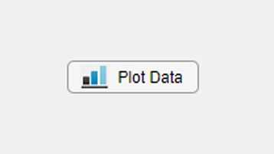 |  | Buttons respond when the user presses and releases them. By changing property values. |  | 5 | Edit field (Number) | 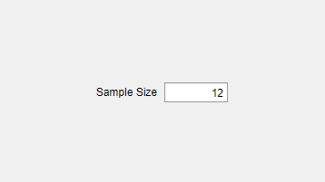 | It accepts numeric value from app user, stores the value.
2 | Check box | 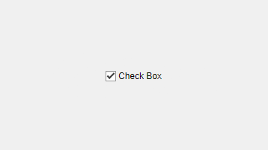 |  | A check box indicates the state of a preference or option. Check boxes are useful when providing the user with a number of independent choices, for example, displaying a toolbar. |  | 6 | Edit field (Text) | 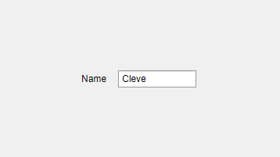 | This component allows the entering and editing of text.
3 | Date pickers | 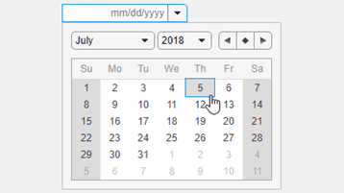 |  | Date pickers allow users to select dates from an interactive calendar. |  | 7 | Image | 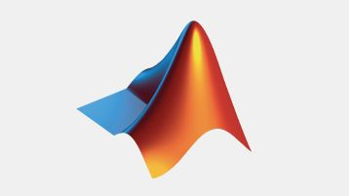 | Image is used to display graphics like photos, icons to improve aesthetic of interface or serves as a sign.
4 | Drop down | 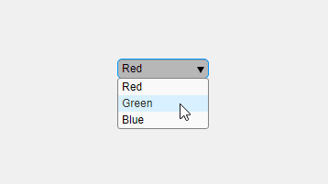 |  | Drop down menu allows user to select from a list of options to be executed by a callback function. |  | 8 | Label | 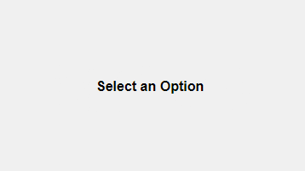 | It serves as a holder for text to label different part of an app.
9 | List Box |  | 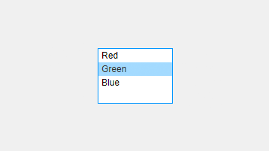 |  | It allows app user to select option from a list of option to be executed in the callback function. | 14 | Panel | 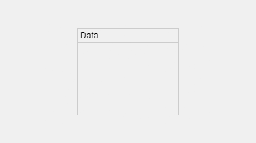 | It is used for grouping together other components.
10 | Radio Button Group |  | 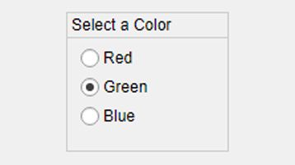 |  | This component allows user to select or deselect from a collection of options with the button group. | 15 | Tab Group | 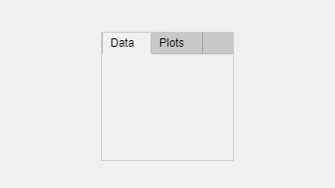 | It allows modules or units to be grouped together as a single app with a tabbed label.
12 | UI Axes |  | 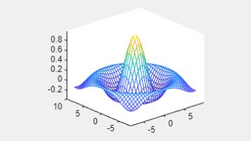 |  | It is used to display axes and never has callback function. It function is to be written in other components callback or function written in them to execute this action. | 16 | Alert | 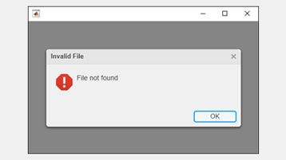 | This component is used to alert user about an action or provide information without t disruption of work-flow
13 | Menu bar |  | 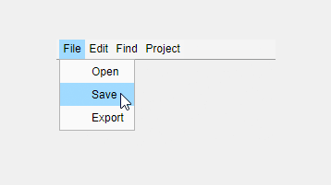 |  | This component provides users with options and, or built-in commands to access the features or functionalities of the app. | 17 | Progress | 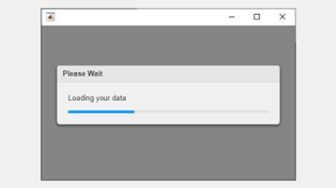 | It provides user with useful feedback on the progress of a task or process.

Creating IR Train /Test User Interface
………………………………………………………………………………………………………………………………………
Step 1 Initializing MATLAB
Launch MATLAB R2021b by double-clicking on the icon on the desktop and typing App Designer over the command window. Then press enter.
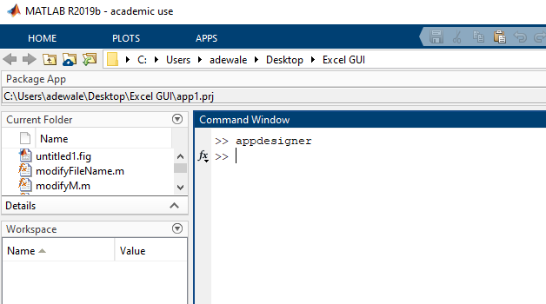Figure S6. Initialization of app designer through the command window
Step 2. App Designer Quick Start
An App Designer quick start window appears with different project templates (classified into new, general, and programming tasks).
- Select “Blank App” as the default template and left-click over it. MATLAB creates a file named app.mlapp

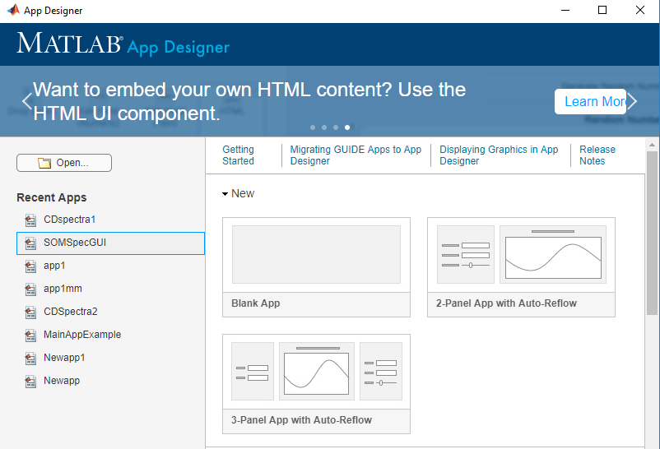
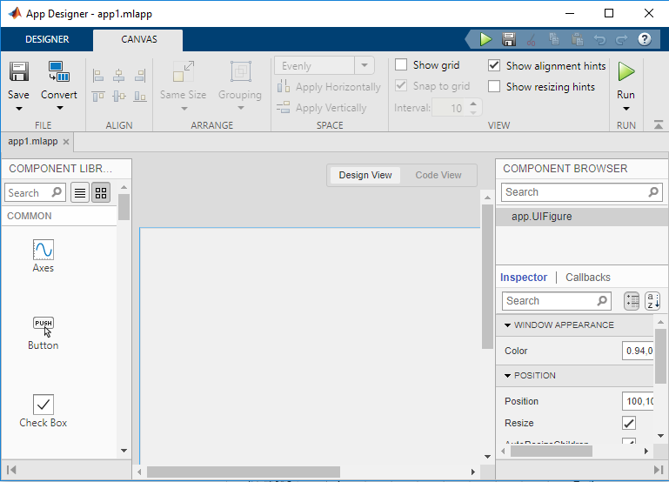
Figure S7. Window with different project templates and selected blank development environment
Step 3. User Interface Layout
Layout, as the word suggests, is the spatial structure of user interactive (UI) components on the screen of app. This step involves adding components to the interface, aligning these components within it, and relabeling the components.
- Drag a push button and drop-down list from the component library and drop them on the app interface.
- Rename the labels on the two components drawn on the interface.
  - To label scheme click on the component and simply delete the existing name. Then type the name you wish to replace that deleted. Alternatively, change the labels of the components in the text box in the ribbon beneath the Inspector > button tab>text.

- Align them into their appropriate position by selecting all, then click on the canvas to evenly space them. These elements may be resized to reduce space within the interface.
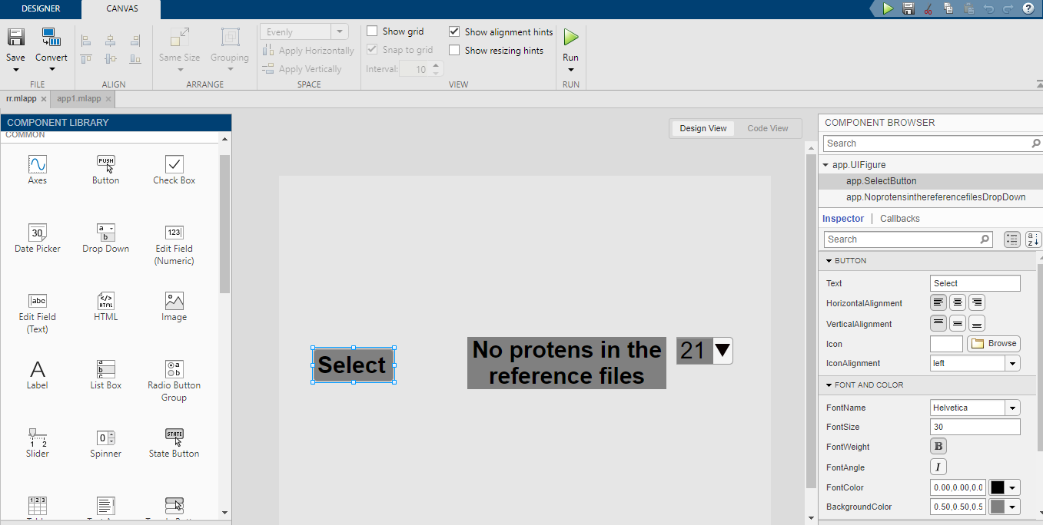
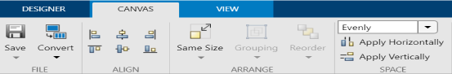
Figure S8. Window with designer and canvas menus for creating user interfaces (modules) and aligning components on the interface respectively.

Step 4. Save the Layout
Save the application interface as “IR test/train” in a mlapp file format by clicking on the SAVE>Save As button under the designer or canvas tab.
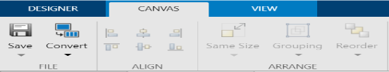
Figure S9. Window with save tab on canvas menu form which user can use to save the application as “IR test/train”.

Step 5. Code the Behaviour of the Application
The interface and its components automatically generate code before writing programming statements in the code view tab to activate the events associated with an element by the developer(s). To retrieve and read an Excel file from the current working directory when the user(s) hits the button named select. Create a callback by right-clicking on the push button and then select Callbacks. Go to selectButtonPushed callback. The callback functions for these actions are the uigetfile and xlsread

Step 6. Repeat step 5 to write code in the callback of the drop down list named “no of proteins in the reference files“.
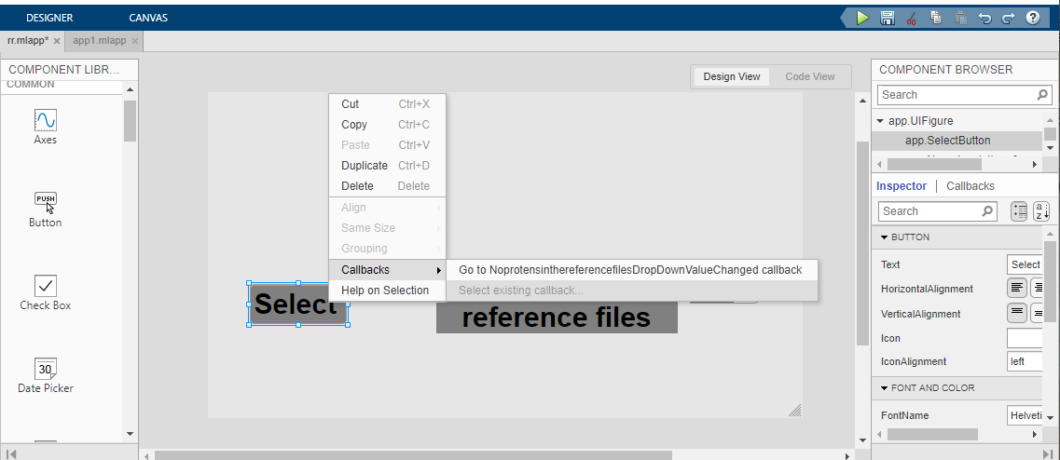
properties (Access = private)
Property % Description
num
end

% Callbacks that handle component events
methods (Access = private)

% Button pushed function: SelectButton
function SelectButtonPushed(app, event)
[file, path] = uigetfile('*.xlsx');
[filepath, filename, fileext] = fileparts(file);
[app.num txt] = xlsread(filename);
End
Figure S10. Window with canvas menus from which user can create callbacks and code wrote in select push button.

Note: To ensure assigned variable can be shared between callbacks and functions, a properties must be added by clicking code view >code browser > properties> (+).
Code Wrote in the Callback of Drop Down List (No of Proteins in the Reference File)
% Callback function: NoprotensinthereferencefilesDropDown,
% SelectButton
function NoprotensinthereferencefilesDropDownValueChanged(app, event)
value = app.NoprotensinthereferencefilesDropDown.Value;
switch app.NoofproteinsinthereferencefileDropDown.Value
case '21'
A = [app.num(:,2:end)];
B = [app.num(:,1), app.num(:,3:end)];
C = [app.num(:,1:2),app.num(:,4:end)];
D = [app.num(:,1:3),app.num(:,5:end)];
E = [app.num(:,1:4),app.num(:,6:end)];
F = [app.num(:,1:5),app.num(:,7:end)];
G = [app.num(:,1:6), app.num(:,8:end)];
H = [app.num(:,1:7), app.num(:,9:end)];
I = [app.num(:,1:8), app.num(:,10:end)];
J = [app.num(:,1:9), app.num(:,11:end)];
K = [app.num(:,1:10), app.num(:,12:end)];
L = [app.num(:,1:11), app.num(:,13:end)];
M = [app.num(:,1:12), app.num(:,14:end)];
N = [app.num(:,1:13), app.num(:,15:end)];
O = [app.num(:,1:14), app.num(:,16:end)];
P = [app.num(:,1:15), app.num(:,17:end)];
Q = [app.num(:,1:16),app.num(:,18:end)];
R = [app.num(:,1:17),app.num(:,19:end)];
S = [app.num(:,1:18),app.num(:,20:end)];
T = [app.num(:,1:19),app.num(:,end)];
U = [app.num(:,1:20)];

% Write the New Set of Proteins as a Train File
writematrix(A,'Rep 1.txt'); writematrix(B,'Rep 2.txt'); writematrix(C,'Rep 3.txt'); writematrix(D,'Rep 4.txt');writematrix(E,'Rep 5.txt'); writematrix(F,'Rep 6.txt'); writematrix(G,'Rep 7.txt'); writematrix(H,'Rep 8.txt'); writematrix(I,'Rep 9.txt'); writematrix(J,'Rep 10.txt'); writematrix(K,'Rep 11.txt'); writematrix(L,'Rep 12.txt'); writematrix(M,'Rep 13.txt'); writematrix(N,'Rep 14.txt'); writematrix(O,'Rep 15.txt'); writematrix(P,'Rep 16.txt'); writematrix(Q,'Rep 17.txt'); writematrix(R,'Rep 18.txt'); writematrix(S,'Rep 19.txt'); writematrix(T,'Rep 20.txt'); writematrix(U,'Rep 21.txt');

% Write the New Set of Proteins as a Train File
writematrix(app.num(:,1),'EP 1.txt'); writematrix(app.num(:,2),'EP 2.txt'); writematrix(app.num(:,3),'EP 3.txt'); writematrix(app.num(:,4),'EP 4.txt');writematrix(app.num(:,5),'EP 5.txt'); writematrix(app.num(:,6),'EP 6.txt'); writematrix(app.num(:,7),'EP 7.txt'); writematrix(app.num(:,8),'EP 8.txt'); writematrix(app.num(:,9),'EP 9.txt'); writematrix(app.num(:,10),'EP 10.txt'); writematrix(app.num(:,11),'EP 11.txt'); writematrix(app.num(:,12),'EP 12.txt'); writematrix(app.num(:,13),'EP 13.txt'); writematrix(app.num(:,14),'EP 14.txt'); writematrix(app.num(:,15),'EP 15.txt'); writematrix(app.num(:,16),'EP 16.txt'); writematrix(app.num(:,17),'EP 17.txt'); writematrix(app.num(:,18),'EP 18.txt'); writematrix(app.num(:,19),'EP 19.txt'); writematrix(app.num(:,20),'EP 20.txt'); writematrix(app.num(:,21),'EP 21.txt');

case '47'
A = [app.num(:,2:end)];
B = [app.num(:,1), app.num(:,3:end)];
C = [app.num(:,1:2),app.num(:,4:end)];
D = [app.num(:,1:3),app.num(:,5:end)];
E = [app.num(:,1:4),app.num(:,6:end)];
F = [app.num(:,1:5),app.num(:,7:end)];
G = [app.num(:,1:6), app.num(:,8:end)];
H = [app.num(:,1:7), app.num(:,9:end)];
I = [app.num(:,1:8), app.num(:,10:end)];
J = [app.num(:,1:9), app.num(:,11:end)];
K = [app.num(:,1:10), app.num(:,12:end)];
L = [app.num(:,1:11), app.num(:,13:end)];
M = [app.num(:,1:12), app.num(:,14:end)];
N = [app.num(:,1:13), app.num(:,15:end)];
O = [app.num(:,1:14), app.num(:,16:end)];
P = [app.num(:,1:15), app.num(:,17:end)];
Q = [app.num(:,1:16),app.num(:,18:end)];
R = [app.num(:,1:17),app.num(:,19:end)];
S = [app.num(:,1:18),app.num(:,20:end)];
T = [app.num(:,1:19),app.num(:,21:end)];
U = [app.num(:,1:20), app.num(:,22:end)];
V = [app.num(:,1:21), app.num(:,23:end)];
W = [app.num(:,1:22), app.num(:,24:end)];
X = [app.num(:,1:23), app.num(:,25:end)];
Y = [app.num(:,1:24), app.num(:,26:end)];
Z = [app.num(:,1:25), app.num(:,27:end)];
AA = [app.num(:,1:26), app.num(:,28:end)];
AB = [app.num(:,1:27), app.num(:,29:end)];
AC = [app.num(:,1:28), app.num(:,30:end)];
AD = [app.num(:,1:29), app.num(:,31:end)];
AE = [app.num(:,1:30),app.num(:,32:end)];
AF = [app.num(:,1:31),app.num(:,33:end)];
AG = [app.num(:,1:32), app.num(:,34:end)];
AH = [app.num(:,1:33), app.num(:,35:end)];
AI = [app.num(:,1:34), app.num(:,36:end)];
AJ = [app.num(:,1:35), app.num(:,37:end)];
AK = [app.num(:,1:36), app.num(:,38:end)];
AL = [app.num(:,1:37), app.num(:,39:end)];
AM = [app.num(:,1:38), app.num(:,40:end)];
AN = [app.num(:,1:39), app.num(:,41:end)];
AO = [app.num(:,1:40), app.num(:,42:end)];
AP = [app.num(:,1:41), app.num(:,43:end)];
AQ = [app.num(:,1:42),app.num(:,44:end)];
AR = [app.num(:,1:43),app.num(:,45:end)];
AS = [app.num(:,1:44),app.num(:,46:end)];
AT = [app.num(:,1:45),app.num(:,end)];
AU = [app.num(:,1:46)];

% Write the New Set of Proteins as a Train File
writematrix(A,'Rep 1.txt'); writematrix(B,'Rep 2.txt'); writematrix(C,'Rep 3.txt'); writematrix(D,'Rep 4.txt');writematrix(E,'Rep 5.txt'); writematrix(F,'Rep 6.txt'); writematrix(G,'Rep 7.txt'); writematrix(H,'Rep 8.txt'); writematrix(I,'Rep 9.txt'); writematrix(J,'Rep 10.txt'); writematrix(K,'Rep 11.txt'); writematrix(L,'Rep 12.txt'); writematrix(M,'Rep 13.txt'); writematrix(N,'Rep 14.txt'); writematrix(O,'Rep 15.txt'); writematrix(P,'Rep 16.txt'); writematrix(Q,'Rep 17.txt'); writematrix(R,'Rep 18.txt'); writematrix(S,'Rep 19.txt'); writematrix(T,'Rep 20.txt'); writematrix(U,'Rep 21.txt'); writematrix(V,'Rep 22.txt'); writematrix(W,'Rep 23.txt'); writematrix(X,'Rep 24.txt'); writematrix(Y,'Rep 25.txt'); writematrix(Z,'Rep 26.txt'); writematrix(AA,'Rep 27.txt'); writematrix(AB,'Rep 28.txt'); writematrix(AC,'Rep 29.txt'); writematrix(AD,'Rep 30.txt'); writematrix(AE,'Rep 31.txt'); writematrix(AF,'Rep 32.txt'); writematrix(AG,'Rep 33.txt'); writematrix(AH,'Rep 34.txt'); writematrix(AI,'Rep 35.txt'); writematrix(AJ,'Rep 36.txt'); writematrix(AK,'Rep 37.txt'); writematrix(AL,'Rep 38.txt'); writematrix(AM,'Rep 39.txt'); writematrix(AN,'Rep 40.txt'); writematrix(AO,'Rep 41.txt'); writematrix(AP,'Rep 42.txt'); writematrix(AQ,'Rep 43.txt'); writematrix(AR,'Rep 44.txt'); writematrix(AS,'Rep 45.txt'); writematrix(AT,'Rep 46.txt'); writematrix(AU,'Rep 47.txt');
% Write Each Protein Removed from the Original Reference Set as a Text File
writematrix(app.num(:,1),'EP 1.txt'); writematrix(app.num(:,2),'EP 2.txt'); writematrix(app.num(:,3),'EP 3.txt'); writematrix(app.num(:,4),'EP 4.txt');writematrix(app.num(:,5),'EP 5.txt'); writematrix(app.num(:,6),'EP 6.txt'); writematrix(app.num(:,7),'EP 7.txt');
writematrix(app.num(:,8),'EP 8.txt');
writematrix(app.num(:,9),'EP 9.txt'); writematrix(app.num(:,10),'EP 10.txt'); writematrix(app.num(:,11),'EP 11.txt'); writematrix(app.num(:,12),'EP 12.txt'); writematrix(app.num(:,13),'EP 13.txt'); writematrix(app.num(:,14),'EP 14.txt'); writematrix(app.num(:,15),'EP 15.txt'); writematrix(app.num(:,16),'EP 16.txt'); writematrix(app.num(:,17),'EP 17.txt'); writematrix(app.num(:,18),'EP 18.txt'); writematrix(app.num(:,19),'EP 19.txt'); writematrix(app.num(:,20),'EP 20.txt'); writematrix(app.num(:,21),'EP 21.txt'); writematrix(app.num(:,22),'EP 22.txt'); writematrix(app.num(:,23),'EP 23.txt'); writematrix(app.num(:,24),'EP 24.txt'); writematrix(app.num(:,25),'EP 25.txt'); writematrix(app.num(:,26),'EP 26.txt'); writematrix(app.num(:,27),'EP 27.txt'); writematrix(app.num(:,28),'EP 28.txt'); writematrix(app.num(:,29),'EP 29.txt'); writematrix(app.num(:,30),'EP 30.txt'); writematrix(app.num(:,31),'EP 31.txt'); writematrix(app.num(:,32),'EP 32.txt'); writematrix(app.num(:,33),'EP 33.txt'); writematrix(app.num(:,34),'EP 34.txt'); writematrix(app.num(:,35),'EP 35.txt'); writematrix(app.num(:,36),'EP 36.txt'); writematrix(app.num(:,37),'EP 37.txt'); writematrix(app.num(:,38),'EP 38.txt'); writematrix(app.num(:,39),'EP 39.txt'); writematrix(app.num(:,40),'EP 40.txt');
writematrix(app.num(:,41),'EP 41.txt'); writematrix(app.num(:,42),'EP 42.txt'); writematrix(app.num(:,43),'EP 43.txt'); writematrix(app.num(:,44),'EP 44.txt'); writematrix(app.num(:,45),'EP 45.txt'); writematrix(app.num(:,46),'EP 46.txt'); writematrix(app.num(:,47),'EP 47.txt');
end

Step 7. Testing the application
Run the “IR train/test app” by hitting on the run button (green rectangle). A window appears immediately with the saved application named on the top-left as in this figure. Select the file ‘IR reference file (S5, Table S7)” from the working directory by clicking on the button (renamed select) then specify the number of proteins in the reference file. Alternatively, to run the GUI app created type its name (IR train/test) the command window or run IR train/test.
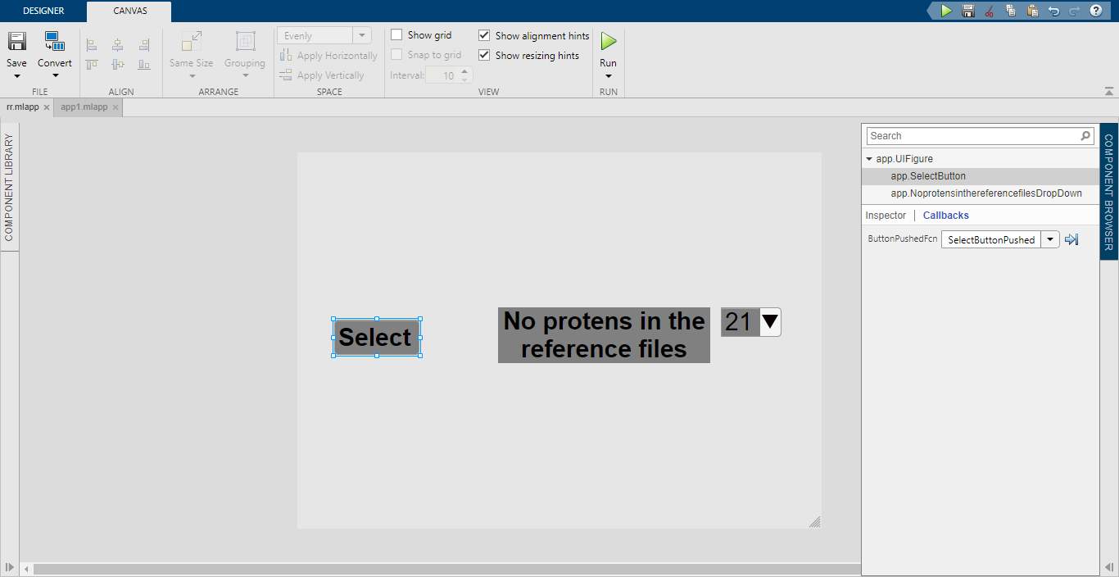
Figure S11. Window with run tab on canvas menu for which user can run the app

Chat Generative Pre-trained Transformer
ChatGPT is a large language model, LLM developed by openAI, built upon its antecedents with capability for conversation artificial intelligence, AI applications. This software uses supervised learning complemented with reinforcement learning, and the LLMs that support it are multimodal compared to earlier chatbox models. ChatGPT works by breaking down prompts from users into sizeable chunks called tokens, followed by comparing the identified patterns and relationships from them with those observed in training data.

ChatGPT Applications
1 | Writing and debugging Code | This tool can help to write and identify potential syntax errors. It provides needed programming assistance in any language and suggestions to fix code bugs in the code snippets.
2 | Data Insight | It can be used to generate patterns, trends, and relevant information from somewhat worthless data, to provide insight about the data.
3 | Creating Plans | This tool assists users in creating schedules for executing plans, offering ideas for activities,etc.
4 | Solving Math Problems | It can attempt to generate step-by-step solutions and explanations for math problems.
5 | Content Creation | It can assist in writing various content like marking materials and blogs.

Books and Articles:
Norden, B, Rodger, A. Dafforn, T. Linear Dichroism and Circular Dichroism. 1st ed. Cambridge; Royal Society Chemistry, 2010, pp 1-47.
Woody, R. W. Circular-Dichroism. Methods in Enzymology 1995, 246, 34-71.
Polavarapu, P. L. Zhao, C. X. Vibrational circular dichroism: a new spectroscopic tool for biomolecular structural determination. Journal Analytical Chemistry, 2000, 366, 727–734.
Kohonen, T. Self-organized formation of topologically correct feature maps. Biology. Cybernetics, 1982, 43, 59-69.
Kohonen, T. Self-organizing Maps. 3rd ed, Berlin; Springer Berlin Heidelberg, 2000, pp 1-6
Chapman, S J. MATLAB Programming for Engineers. 4th ed. Ontario; Thompson, 2001, pp 1–17.
Simakov S. Introduction to MATLAB Graphical User Interfaces. 1st ed. Edinburgh; DSTO Defence Science and Technology Organisation, 2005, pp 1-16.
Web Sites:
ChatGPT. Available from: https://www.techopedia.com/definition/34933/chatgpt (accessed March 2024).
ChatGPT. Available from: https://en.wikipedia.org/wiki/ChatGPT (accessed February 2024).
Chapter 2: Protein Structure. Available from:https://wou.edu/chemistry/courses/online-chemistry-textbooks/ch450-and-ch451-biochemistry-defining-life-at-the-molecular-level/chapter-2-protein-structure/ (accessed September 2023).
Beta Strand, Beta Sheet and Beta Barrel. Available from: http://www.webbooks.com/MoBio/Free/Ch2C6.htm> (accessed September 2023).

S2: TEACHER NOTE
This note specifically serves as add-on to the lecture note given to the students to review during the lectures before the practical sessions. It contains information, instructions, teaching strategies and important points that should be covered by the instructors.
Learning Objectives
- Explain self-organizing map and state its working principles.
- Calculate the concentration of protein sample using the molar extinction value at specific wavelength and expression for this.
- Draw the interface to prepare train and test files form infrared reference, IR reference file for validation approach.
- Explain circular dichroism and interconvert CD units.
Instructions
Materials

MATLAB software, SOMSpec software, lysozyme, insulin, IR protein reference file, distilled water, centrifugal filters, phosphate buffered saline, portable computer

Preparation
- Review lecture note and helpful resources on each of the core concepts and important points to be covered.
- Practice to draw the IR train/test interface and the modules that made up the CD derand app in the answer (sample CD derand app created by instructor) section below.
- Write code for each component in the code view to execute the actions associated with it.
- Test the app to see if the push button pushes and other components used function as should be.

Suggested Activity and Teaching Points (Presentation)
- Introduce the principle of circular dichroism spectroscopy and its applications by reviewing in succession circular dichroism, CD units and inter-conversion, how CD signal are produce, CD spectra for different secondary structures, etc.
- Ask each group to write out the conversion from millidegree to molar extinction to absorbance without reviewing or reading the laboratory note on the spot. Instruct them to code this on MATLAB command window using any hypothetical values for concentration, pathlength, and mean weight residue.
- Review the intelligent system (SOM) which our structure algorithm (SOMSpec) is based on. Highlight and reiterate the important points on this.
- Briefly describe SOMSpec and demonstrate how to use it. Give examples of its applications.
- Review the concept of concentration of solutions, moles, dilution factor.
- Provide students with the published molar extinction coefficient of lysozyme and insulin at Absorbance of 280 nm, and the expression that relates concentration to molar extinction and absorbance to enable them to calculate the actual concentration of protein.
- Walk them through the step-by-step of operating UV spectrophotometer to collect Absorbance spectra of proteins, as well as CD machine to collect CD spectra of proteins as a function of temperature or other conditions.
- Demonstrate how to create GUI using the IR train/test app as an example.
- Instruct students to create app that can retrieve, read and write, and then when required plot the final data; perform subtraction of a baseline; convert spectra from millidegrees to delta epsilon units; scale the spectra by a given factor; derandomize original spectra; merge file together into one file; convert txt file output of self-organising map spectroscopy (SOMSpec) to xlsx file.
- Advise the students to either write or debug the code for each module using ChatGPT.

Answer: Sample CD derand App Created by Instructor
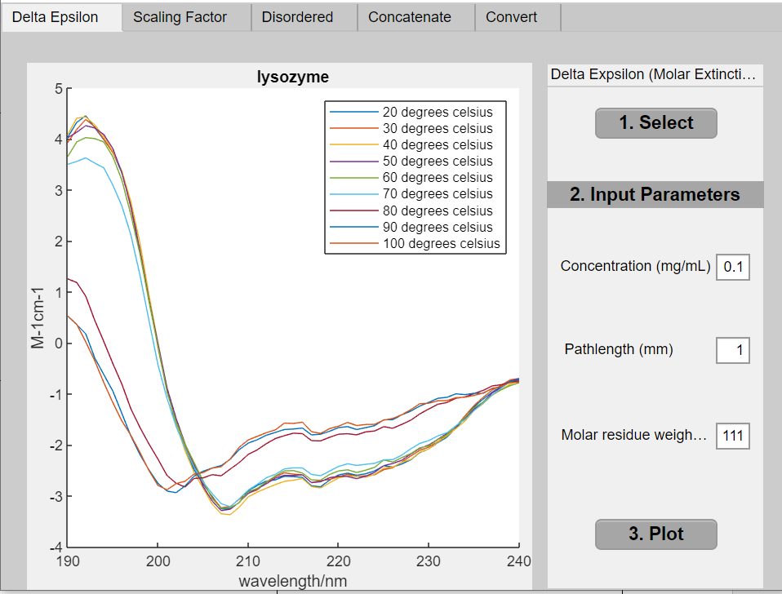  (a) | 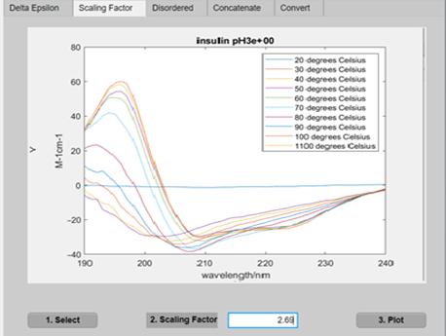 |  | 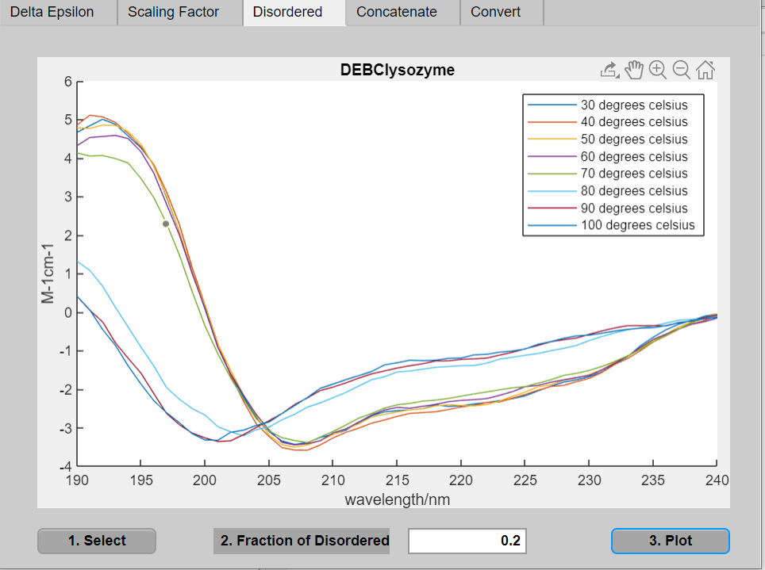  (c)
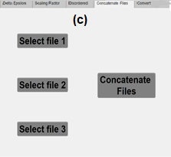 |  | 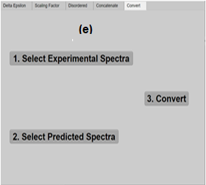
Figure S11. The output figures of the modules that makes up the CD derand app: (a) delta epsilon, (b) scaling factor, (c) disordered, (d) concatenate, (e) convert.
Note: Data files generated by each module are not shown (the instructors use the ones generated by the respective app they created to grade that obtained by the students)
Answer: Generic Code Written in the Callback of Each Module of the App
Code Set in Delta Epsilon Module
%Select file
[file, path] = uigetfile ('*.xlsx');
[filepath, filename, fileext] = fileparts(file);
app.FFilename = filename
[app.num app.txt] = xlsread (app.FFilename);
app.txt1 = app.txt(:,3:end);
app.numS = app.num(:,3:end);
app.numB = app.num(:,2);

%Concentration Callback
value = app.ConcentrationmgmLEditField.Value;

%Pathlength Callback
value = app.PathlengthnmEditField.Value;

%Mean Residue Weight Callback
value = app.MeanResidueWeightgmolEditField.Value;

%Plot Callback
data1 = app.numS* app.MeanResidueWeight
gmolEditField.Value/(32980* app.Concentratio
nmgmLEditField.Value *0.1* app.Pathlengthnm
EditField.Value);
BCdata = data1- app.numB;
plot (app.UIAxes, app.num(:,1), BCdata);
title (app.UIAxes, app.FFilename);
legend (app.UIAxes, app.txt1);
xlabel (app.UIAxes,'wavelength/nm');
ylabel (app.UIAxes,'M-1cm-1');
fileName = strcat('DEBC',app.FFilename);
N=[app.txt(:, 1),app.txt1];
data_cellsbc = num2cell (data1);
data_cellsn = num2cell (app.num(:,1));
M = [data_cellsn,data_cellsbc];
J = [N; M];
xlswrite(app.FFileName,J);

Code Set in Scaling Factor Module
%Select File Callback
[file, path] = uigetfile('*.xlsx');
[filepath, filename, fileext] = fileparts(file);
app.fileName = filename;
[num txt raw] = xlsread(app.fileName);
app.scale1 = num(:,1);
app.scale2 = num(:,2:end);
app.txts1 = txt(:,1);
app.txt2 = txt(:,2:end);
%Scaling Factor Callback
app.scalingfactor = app.ScalingfactorEditField.Value;

%Plot Calback
app.ScalefileName4 = app.scale2.*app.scalingfactor;
S = sprintf('%.d', app.scalingfactor)
%S = num2str(app.scalingfactor);
filename = strcat(app.fileName, S);
plot(app.UIAxes2,app.scale1,app.ScalefileName4);
xlabel(app.UIAxes2,'wavelength/nm');
ylabel(app.UIAxes2,'M-1cm-1');
title(app.UIAxes2, filename);
legend(app.UIAxes2, app.txt2);
num1 = num2cell (app.scale1); num2 = num2cell (app.ScalefileName4);
H = [app.txts1, app.txt2; num1, num2];
xlswrite (filename,H);

Code Set in Disordered Module
%Select Callback
[file, path] = uigetfile ('*.xlsx');
[filepath, filename, fileext] = fileparts(file);
app.FFilename = filename;
[num txt raw] = xlsread(app.FFilename);
app.wavelength = num (:,1);
app.dataR = num(:,2);
app.dataS = num(:,3:end);
app.txtN1 = txt(:,1);
app.txtD = txt(:,3: end);

%Fraction of Disordered Callback
app.fractiondisordered=app.FractionofDisorderedEditField.Value;

%Plot Callback
DataSD = (app.dataS - app.fractiondisordered *app.dataR)/(1-app.fractiondisordered);
S = sprintf('%.d', app.fractiondisordered);
filename = strcat(app.filenamess,S);
plot(app.UIAxes3, app.wavelength, DataSD);
xlabel(app.UIAxes3,'wavelength/nm');
ylabel(app.UIAxes3,'M-1cm-1');
title (app.UIAxes3,app.filenamess);
legend(app.UIAxes3,app.txtD);
Wavelength = num2cell (app.wavelength);
Data_SD = num2cell (DataSD)
L = [app.txtN1, app.txtD; Wavelength, Data_SD]
M = [app.wavelength, DataSD];
xlswrite(filename,L);
dlmwrite(filename,M);

Code Set in Concatenate Module
%Seletfile1 Callback
[file, path] = uigetfile ('*.xlsx');
[filepath, filename, fileext] = fileparts(file);
[app.num4 txt app.raw] = xlsread (filename);
%Seletfile2 Callback
[file, path] = uigetfile('*.xlsx');
[filepath, filename, fileext] = fileparts(file);
[app.num5 txt app.raw1] = xlsread(filename);

%Seletfile3 Callback
[file, path] = uigetfile('*.xlsx');
[filepath, filename, fileext] = fileparts(file);
[app.num6 txt app.raw2] = xlsread(filename);

%Concatenate Callback
J=[app.num4(:,2:end),
app.num5(:,2:end),
app.num6(:,2:end)];
H = [app.raw,app.raw1(:,2:end),app.raw2(:,2:end)];
dlmwrite('concatenate file.txt',J);
xlswrite ('concatenate file.xlsx',H);

Code Set in Convert Module
%SelectSpectra_Real Callback

fileN = uigetfile('*.txt');
app.Select1 = dlmread(fileN);

%SelectSpectra_Predicted Callback
fileN1 = uigetfile ('*.txt');
app.Select2 = dlmread (fileN1);

%Convert Callback:
fileName = strcat ('T', 'Spectra_Real');
fileNameI = strcat('T', 'Spectra_Predicted');
Spectra_Real = app.Select1';
Spectra_Predicted = app.Select2';
T = linspace (240,190,200);
Wavelength = T';
H = [Wavelength, Spectra_Real]
I = [Wavelength, Spectra_Predicted]
xlswrite (fileName,H);
xlswrite (fileNameI,I);

