Clinical Therapy Dose Optimization of Sublingual Buprenorphine in poorly adherent pregnant patients: A PBPK translational modelling Study
Supplementary Material Section
Table 1. Summary of baseline predicted buprenorphine pharmacokinetic metrics before Rifampicin treatment at selected weeks in each gestational trimester.
 | Statistics | AUC (ng/ml.h) | Cmax (ng/ml) | Cmin (ng/ml) | Tmax (h) | CL (L/hr)
 | Mean (SD) | 57.40 (15.95) | 8.12 (2.11) | 0.30 (0.17) | 1.21 (0.26) | 299.65 (84.44)
GW 5  (First Trimester) | Minimum Value | 21.83 | 3.83 | 0.02 | 0.60 | 152.87
GW 5  (First Trimester) | Maximum Value | 104.66 | 13.87 | 0.72 | 1.90 | 732.78
GW 5  (First Trimester) | Fold | 4.79 | 3.62 | 44.23 | 3.17 | 4.79
GW 5  (First Trimester) | 5th percentile | 37.60 | 4.91 | 0.04 | 0.75 | 184.53
 | 95th percentile | 86.73 | 11.92 | 0.66 | 1.65 | 425.51
 | Mean (SD) | 49.28 (12.22) | 6.98 (1.80) | 0.29 (0.15) | 1.13 (0.25) | 344.99 (90.11)
GW 20  (Second Trimester) | Minimum Value | 20.59 | 3.53 | 0.02 | 3.53 | 186.49
GW 20  (Second Trimester) | Maximum Value | 85.80 | 12.21 | 0.65 | 12.21 | 777.17
GW 20  (Second Trimester) | Fold | 4.417 | 3.46 | 36.91 | 3.08 | 4.17
GW 20  (Second Trimester) | 5th percentile | 33.28 | 4.23 | 0.05 | 0.70 | 223.45
 | 95th percentile | 71.61 | 10.04 | 0.57 | 1.55 | 480.75
 | Mean (SD) | 42.90 (9.71) | 6.09 (1.57) | 0.28 (0.13) | 1.16 (0.23) | 393.39 (98.00)
GW 35  (Third Trimester) | Minimum Value | 19.33 | 2.86 | 0.02 | 0.70 | 219.77
GW 35  (Third Trimester) | Maximum Value | 72.80 | 10.93 | 0.61 | 1.80 | 827.70
GW 35  (Third Trimester) | Fold | 3.77 | 3.82 | 26.39 | 2.57 | 3.77
GW 35  (Third Trimester) | 5th percentile | 29.24 | 3.66 | 0.05 | 0.75 | 264.93
 | 95th percentile | 60.39 | 8.76 | 0.51 | 1.55 | 547.24
AUC - area under the curve; tmax - time to maximum concentration; Cmax maximum concentration (peak); Cmin - minimum (trough) concentrations; CL - total clearance; GW – gestational week. Pharmacokinetic parameters expressed as mean (standard deviation).
Table 2. Summary of predicted BUP pharmacokinetic metrics after Rifampicin 600mg once daily dosing with interaction (Inducer).
 | Statistics | AUCind  (ng/ml.h) | C_{max}ind  (ng/ml) | C_{min}ind  (ng/ml) | t_{max}ind  (h) | CLind  (L/hr) | AUC  Ratio | Cmax Ratio
 | Mean (SD) | 31.95(6.48)** | 5.40(1.50)** | 0.12(0.07)** | 1.07 (0.22)** | 525.42(128.63)** | 0.57(0.09) | 0.67(0.09)
GW 5  (First Trimester) | Minimum Value | 15.91 | 2.48 | 0.00 | 0.55 | 326.39 | 0.36 | 0.45
GW 5  (First Trimester) | Maximum Value | 49.02 | 10.83 | 0.33 | 1.65 | 1005.51 | 0.76 | 0.83
GW 5  (First Trimester) | Fold | 3.08 | 4.36 | 91.22 | 3.00 | 3.08 | 2.09 | 1.87
GW 5  (First Trimester) | 5th percentile | 20.96 | 3.17 | 0.01 | 0.70 | 387.99 | 0.39 | 0.53
 | 95th percentile | 41.24 | 7.81 | 0.23 | 1.40 | 736.54 | 0.71 | 0.81
 | Mean (SD) | 30.65(5.85)** | 5.05(1.43)** | 0.13(0.07)** | 1.01(0.22)** | 545.73(131.02)** | 0.63(0.09) | 0.72(0.08)
GW 20  (Second Trimester) | Minimum Value | 15.31 | 2.14 | 0.01 | 0.55 | 368.90 | 0.42 | 0.50
GW 20  (Second Trimester) | Maximum Value | 43.37 | 10.55 | 0.33 | 1.60 | 1045.16 | 0.80 | 0.87
GW 20  (Second Trimester) | Fold | 2.83 | 4.93 | 53.76 | 2.91 | 2.83 | 1.91 | 1.74
GW 20  (Second Trimester) | 5th percentile | 20.13 | 2.95 | 0.01 | 0.65 | 416.53 | 0.46 | 0.60
 | 95th percentile | 38.41 | 7.24 | 0.26 | 1.35 | 794.77 | 0.76 | 0.84
 | Mean (SD) | 29.35(5.46)** | 4.71(1.33)** | 0.16(0.08)** | 1.07 (0.21)** | 569.29(136.81)** | 0.69(0.08) | 0.77(0.07)
GW 35  (Third Trimester) | Minimum Value | 13.86 | 1.88 | 0.01 | 0.65 | 400.18 | 0.48 | 0.55
GW 35  (Third Trimester) | Maximum Value | 39.98 | 9.71 | 0.33 | 1.60 | 1154.05 | 0.85 | 0.89
GW 35  (Third Trimester) | Fold | 2.88 | 5.17 | 31.61 | 2.46 | 2.88 | 1.78 | 1.62
GW 35  (Third Trimester) | 5th percentile | 19.48 | 0.54 | 0.66 | 0.75 | 438.38 | 0.54 | 0.66
 | 95th percentile | 36.50 | 0.81 | 0.87 | 1.40 | 821.28 | 0.81 | 0.87
‘ind’ refers to pharmacokinetic metric in the presence of rifampicin; AUC – area under the curve; tmax – time to maximum concentration; Cmax maximum concentration (peak); Cmin – minimum (trough) concentrations; CL – total clearance; AUC Ratio – AUC without inhducer/AUCwith inducer; Cmax Ratio – Cmax without inducer/Cmax with inducer, GW – gestational week; ** indicates statistical significance denoted by p < 0.05. The paired t-test was utilized to determine p-values for all parameters except tmax, where the Kruskall-Wallis test was used. Pharmacokinetic parameters expressed as mean (standard deviation)
Table 3. Summary of predicted buprenorphine pharmacokinetic parameters before Clarithromycin dosing at selected weeks in each trimester.
 | Statistics | AUC  (ng/ml.h) | C_{max}  (ng/ml) | C_{min}  (ng/ml) | tmax  (h) | CL  (L/hr)
 | Mean (SD) | 56.34 (15.74) | 7.79 (1.99) | 0.29 (0.17) | 1.24 (0.27) | 302.67 (73.49)
GW 5  (First Trimester) | Minimum Value | 28.71 | 4.11 | 0.01 | 0.65 | 141.91
GW 5  (First Trimester) | Maximum Value | 112.74 | 14.48 | 0.97 | 1.85 | 557.35
GW 5  (First Trimester) | Fold | 3.93 | 3.52 | 79.40 | 2.85 | 3.93
GW 5  (First Trimester) | 5th percentile | 39.33 | 4.84 | 0.03 | 0.85 | 191.51
 | 95th percentile | 83.68 | 11.68 | 0.53 | 1.70 | 406.80
 | Mean (SD) | 48.64 (11.61) | 6.71 (1.61) | 0.29 (0.14) | 1.17 (0.26) | 345.92 (76.69)
GW 20  (Second Trimester) | Minimum Value | 25.67 | 3.77 | 0.02 | 0.60 | 182.94
GW 20  (Second Trimester) | Maximum Value | 87.46 | 11.52 | 0.78 | 1.80 | 623.26
GW 20  (Second Trimester) | Fold | 3.41 | 3.06 | 45.50 | 3.00 | 3.41
GW 20  (Second Trimester) | 5th percentile | 33.97 | 4.20 | 0.04 | 0.80 | 232.56
 | 95th percentile | 68.89 | 9.49 | 0.48 | 1.60 | 470.98
 | Mean (SD) | 42.56 (8.88) | 5.87 (1.36) | 0.28 (0.12) | 1.20 (0.25) | 391.93 (81.33)
GW 35  (Third Trimester) | Minimum Value | 23.14 | 3.37 | 0.02 | 0.65 | 225.84
GW 35  (Third Trimester) | Maximum Value | 70.85 | 9.41 | 0.63 | 1.75 | 691.49
GW 35  (Third Trimester) | Fold | 3.06 | 2.79 | 25.56 | 2.69 | 3.06
GW 35  (Third Trimester) | 5th percentile | 29.69 | 3.70 | 0.06 | 0.85 | 277.93
 | 95th percentile | 57.60 | 8.19 | 0.47 | 1.60 | 538.82
AUC – area under the curve; tmax - time to maximum concentration; Cmax maximum concentration (peak); Cmin - minimum (trough) concentrations; CL - total clearance; GW – gestational week; Pharmacokinetic parameters expressed as mean (standard deviation).
Table 4 Summary of predicted buprenorphine pharmacokinetic parameters after Clarithromycin 500mg twice daily dosing with interaction (Inhibitor).
 | Statistics | AUCinh  (ng/ml.h) | Cmaxinh  (ng/ml) | Cmininh  (ng/ml) | tmaxinh  (h) | AUC Ratio | Cmax Ratio | CLinh  (L/hr)
 | Mean (SD) | 83.00 (34.80)** | 10.37 (3.32)** | 0.53 (0.42)** | 1.34 (0.30)** | 1.44 (0.25) | 1.32 (0.17) | 218.49 (70.52)**
GW 5  (First Trimester) | Minimum Value | 38.26 | 5.11 | 0.02 | 0.75 | 1.12 | 1.08 | 70.44
GW 5  (First Trimester) | Maximum Value | 227.13 | 21.16 | 2.49 | 2.10 | 2.83 | 2.23 | 418.25
GW 5  (First Trimester) | Fold | 5.94 | 4.14 | 143.40 | 2.80 | 2.52 | 2.07 | 5.94
GW 5  (First Trimester) | 5th percentile | 47.15 | 6.13 | 0.07 | 0.90 | 1.16 | 1.13 | 106.13
 | 95th percentile | 150.78 | 17.00 | 1.04 | 1.90 | 1.83 | 1.59 | 339.38
 | Mean (SD) | 68.76 (26.48)** | 8.61 (2.60)** | 0.49 (0.34)** | 1.26 (0.29)** | 1.39 (0.24) | 1.28 (0.16) | 259.11 (77.78)**
GW 20  (Second Trimester) | Minimum Value | 32.37 | 4.30 | 0.02 | 0.70 | 1.10 | 1.06 | 87.51
GW 20  (Second Trimester) | Maximum Value | 182.84 | 17.28 | 2.06 | 1.90 | 2.85 | 2.21 | 494.35
GW 20  (Second Trimester) | Fold | 5.65 | 4.02 | 86.92 | 2.71 | 2.58 | 2.09 | 5.65
GW 20  (Second Trimester) | 5th percentile | 41.14 | 5.41 | 0.06 | 0.85 | 1.13 | 1.10 | 130.27
 | 95th percentile | 122.84 | 13.64 | 0.95 | 1.75 | 1.77 | 1.51 | 388.89
 | Mean (SD) | 58.22 (21.05)** | 7.34 (2.14)** | 0.46 (0.29)** | 1.28 (0.27)** | 1.34 (0.25) | 1.24 (0.17) | 302.61 (86.22)**
GW 35  (Third Trimester) | Minimum Value | 28.32 | 3.74 | 0.04 | 0.75 | 1.06 | 1.04 | 104.83
GW 35  (Third Trimester) | Maximum Value | 152.63 | 14.58 | 1.81 | 1.85 | 2.92 | 2.24 | 565.06
GW 35  (Third Trimester) | Fold | 5.39 | 3.90 | 49.72 | 2.47 | 2.75 | 2.16 | 5.39
GW 35  (Third Trimester) | 5th percentile | 37.11 | 4.37 | 0.08 | 0.90 | 1.09 | 1.07 | 155.85
 | 95th percentile | 102.68 | 11.28 | 0.83 | 1.75 | 1.75 | 1.49 | 431.18
‘inh’ refers to pharmacokinetic metric in the presence of Clarithromycin; AUC – area under the curve; tmax – time to maximum concentration; Cmax maximum concentration (peak); Cmin - minimum (trough) concentrations; CL - total clearance; AUC Ratio - AUC without inhibitor/AUCwith inhibitor; Cmax Ratio - Cmax without inhibitor/Cmax with inhibitor; GW – gestational week; ** indicates statistical significance denoted by P < 0.05. The paired t-test was used to determine p-values for all parameters except tmax, where the Kruskall-Wallis test was used; Pharmacokinetic parameters expressed as mean (standard deviation).
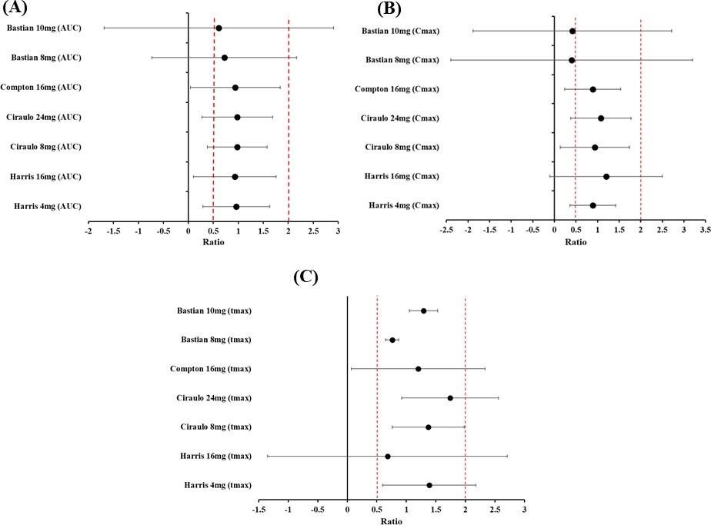
Figure 1. Forest plots displaying the predicted mean ± standard deviation over the observed ratio of model predicted sublingually administered Buprenorphine pharmacokinetic metrics.
(A - AUC, B - Cmax, C- tmax) in subjects, with the dashed (vertical red) lines representing the twofold range window (0.5–2.0).

