Supplementary Documents:
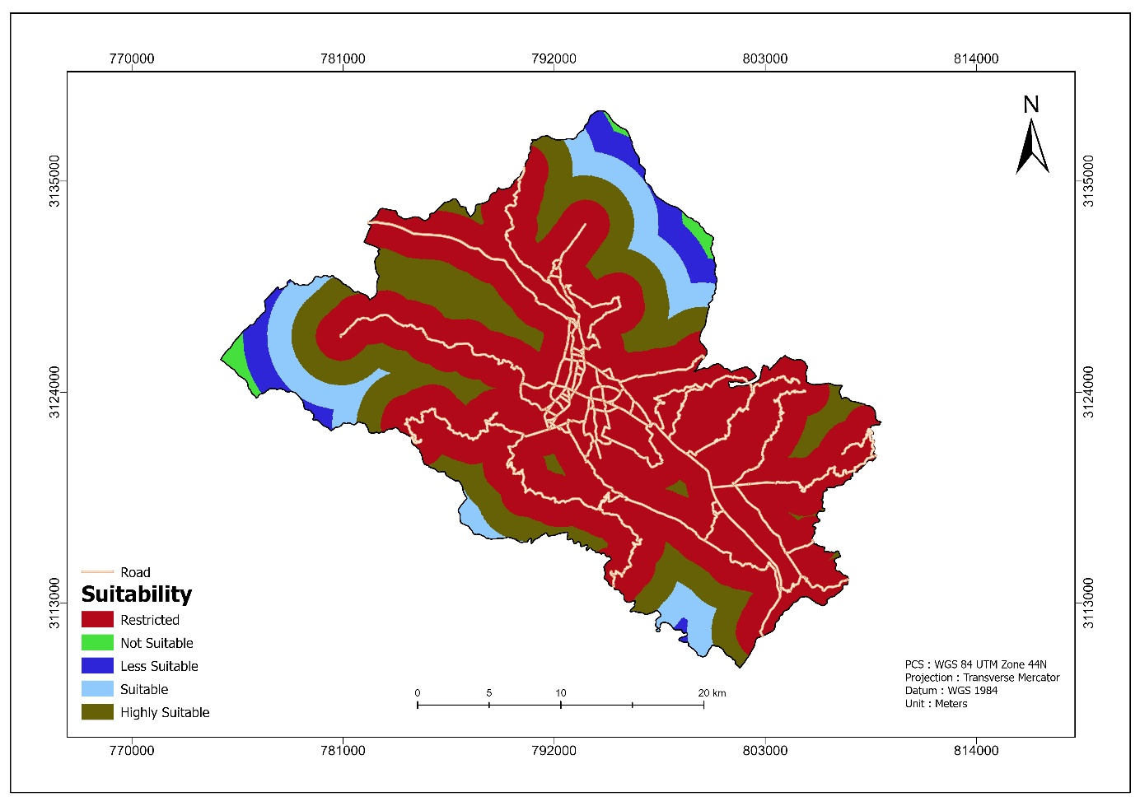
Figure 1Suitability of distances from roads to optimize landfill siting in Pokhara Metropolitan City, Nepal as of July 2025.
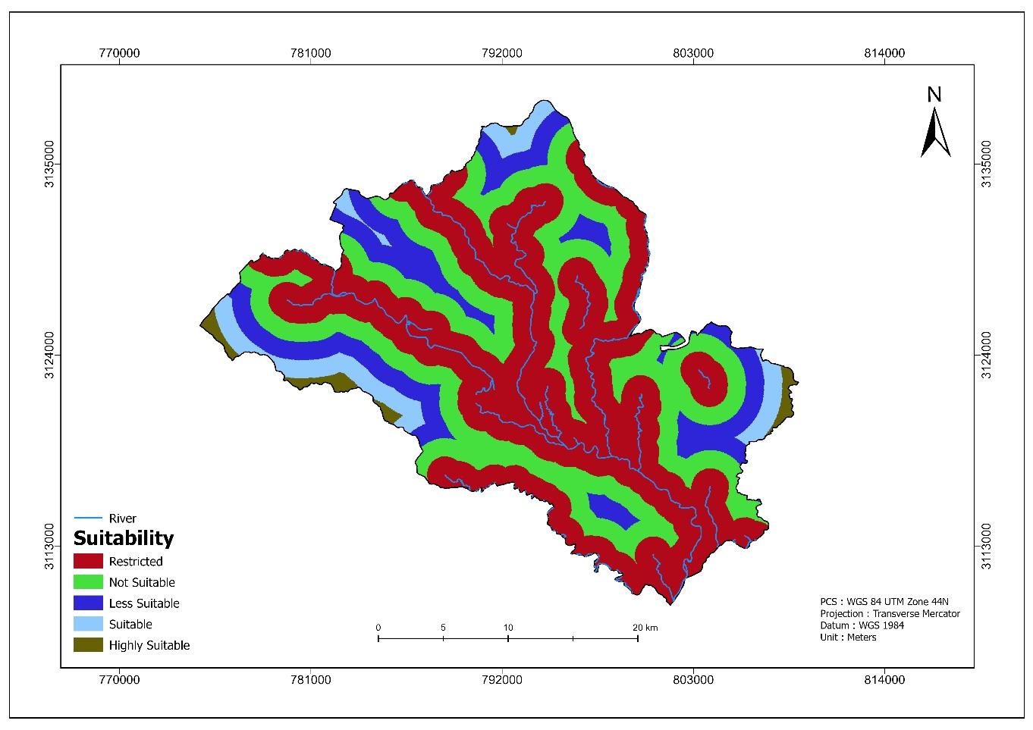
Figure 2 Suitability of distances from rivers to optimize landfill siting in Pokhara Metropolitan City, Nepal as of July 2025.
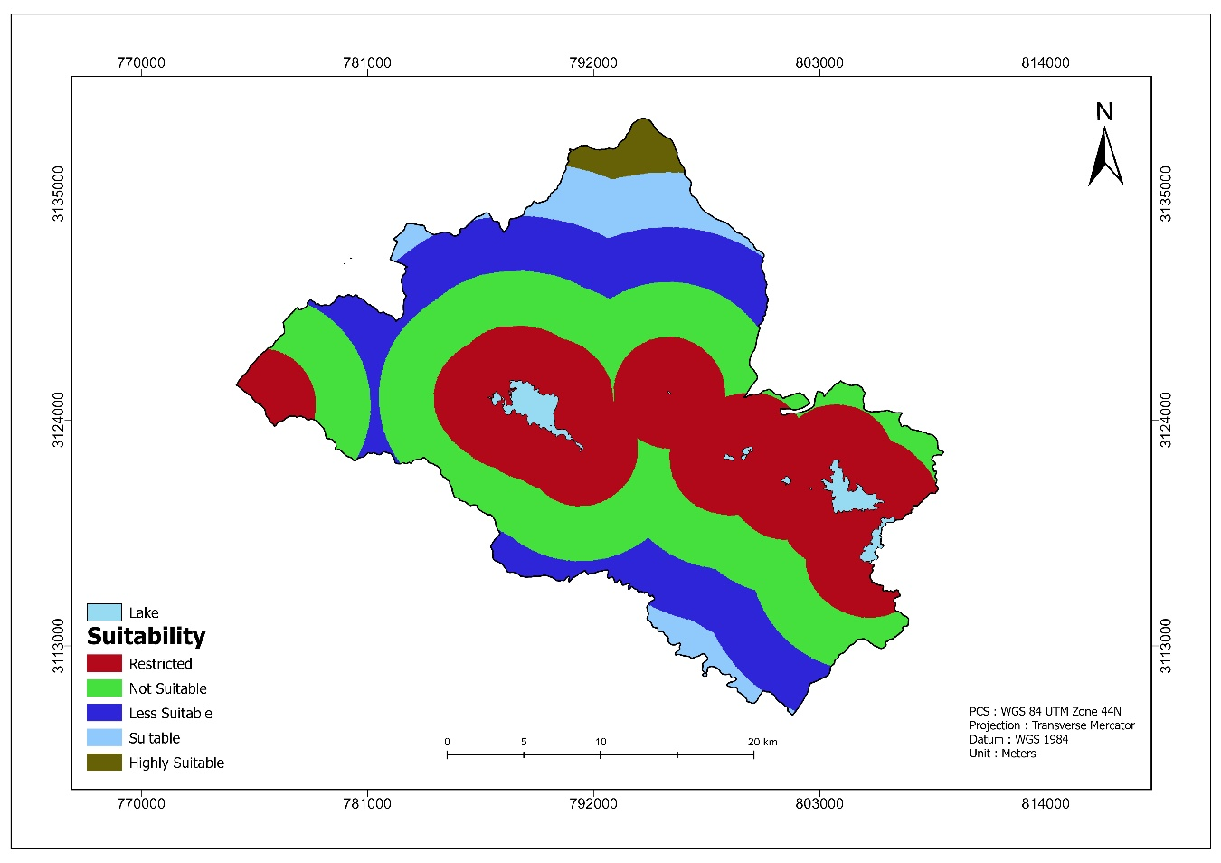
Figure 3 Suitability of distances from lakes to optimize landfill siting in Pokhara Metropolitan City, Nepal as of July 2025.
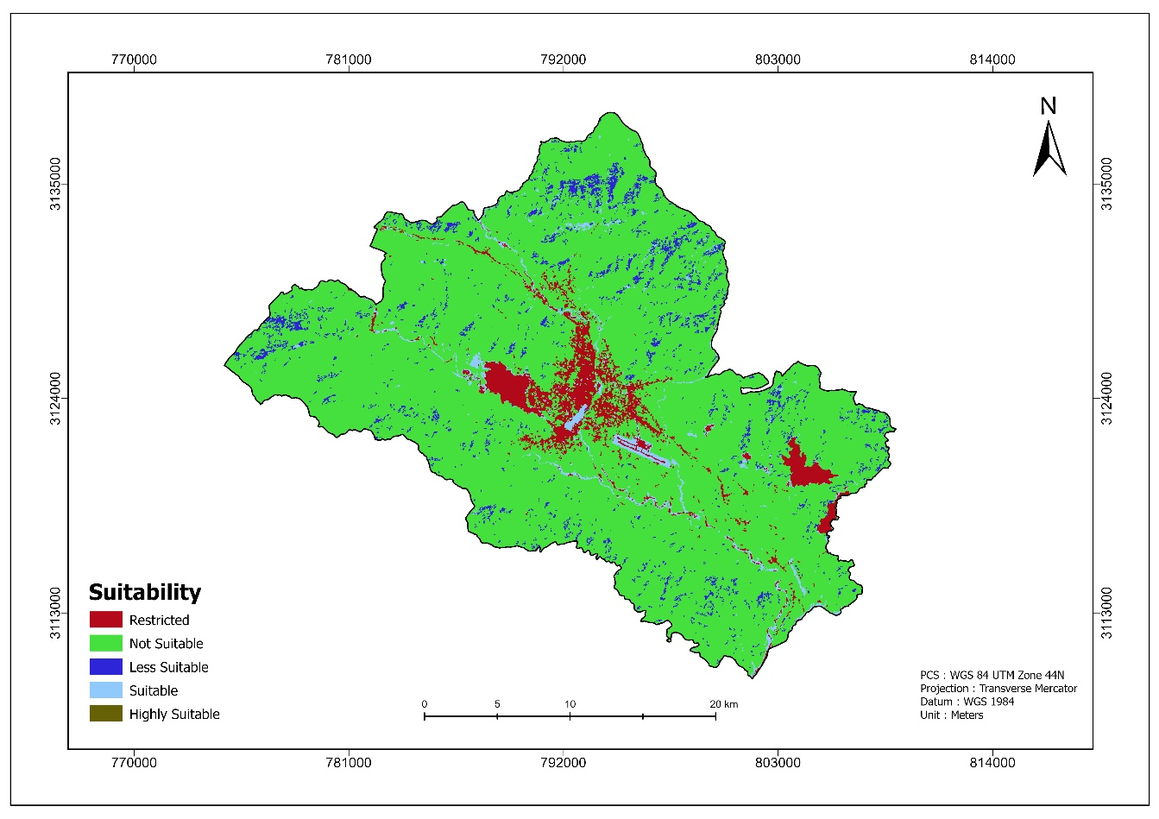
Figure 4 Suitability of Land Use and Land cover Classification to optimize landfill siting in Pokhara Metropolitan City, Nepal as of July 2025.

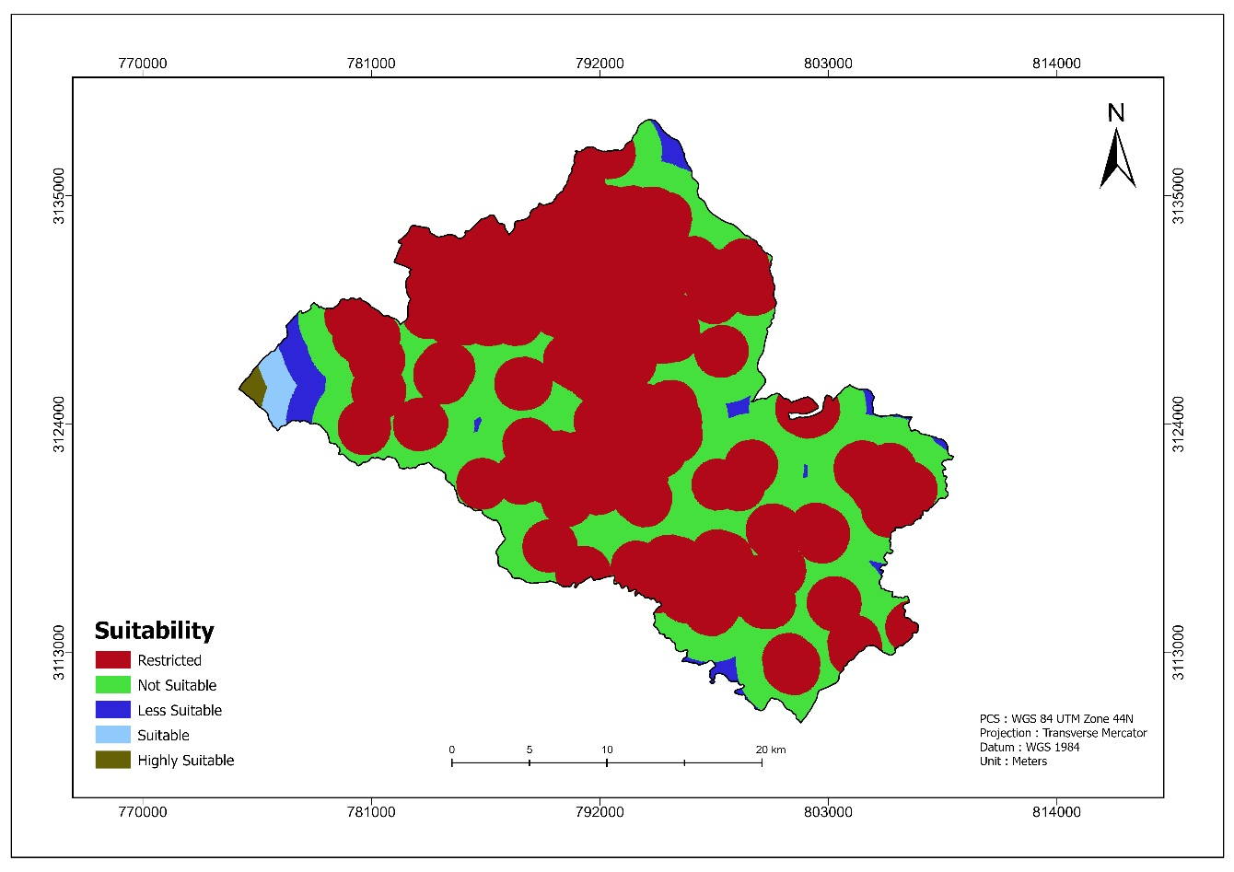
Figure 5 Suitability of buffer from settlements to optimize landfill siting in Pokhara Metropolitan City, Nepal as of July 2025.
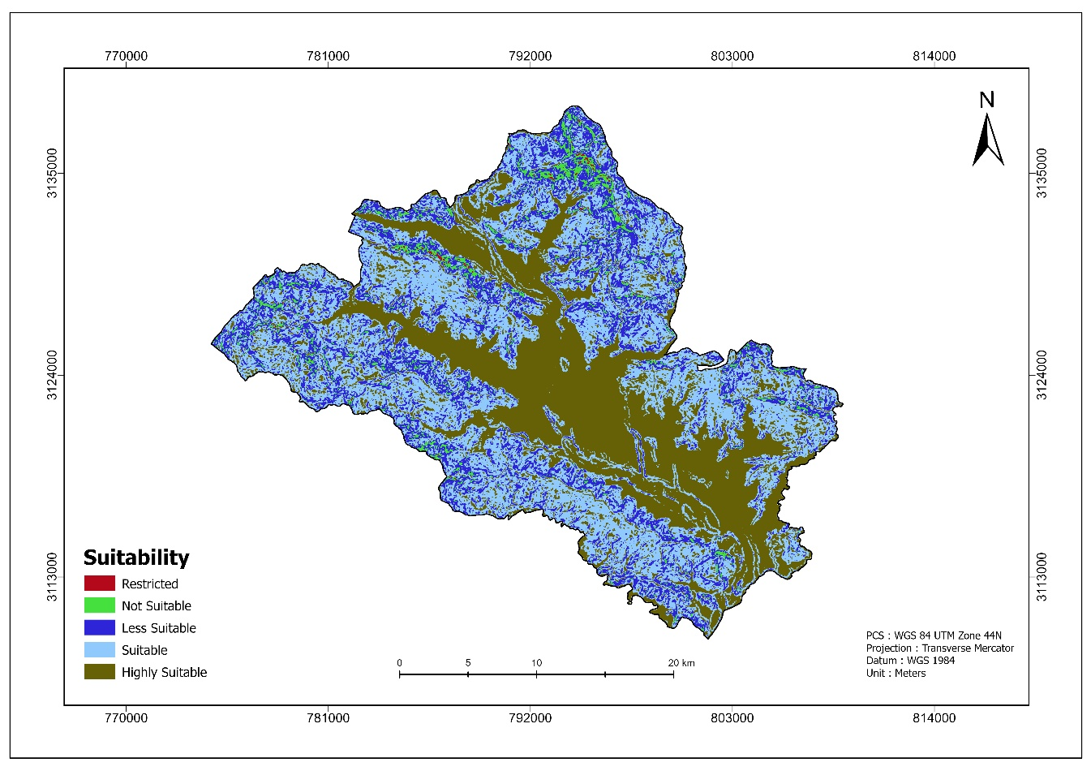
Figure 6 Suitability of slope Evaluation to optimize landfill siting in Pokhara Metropolitan City, Nepal as of July 2025.

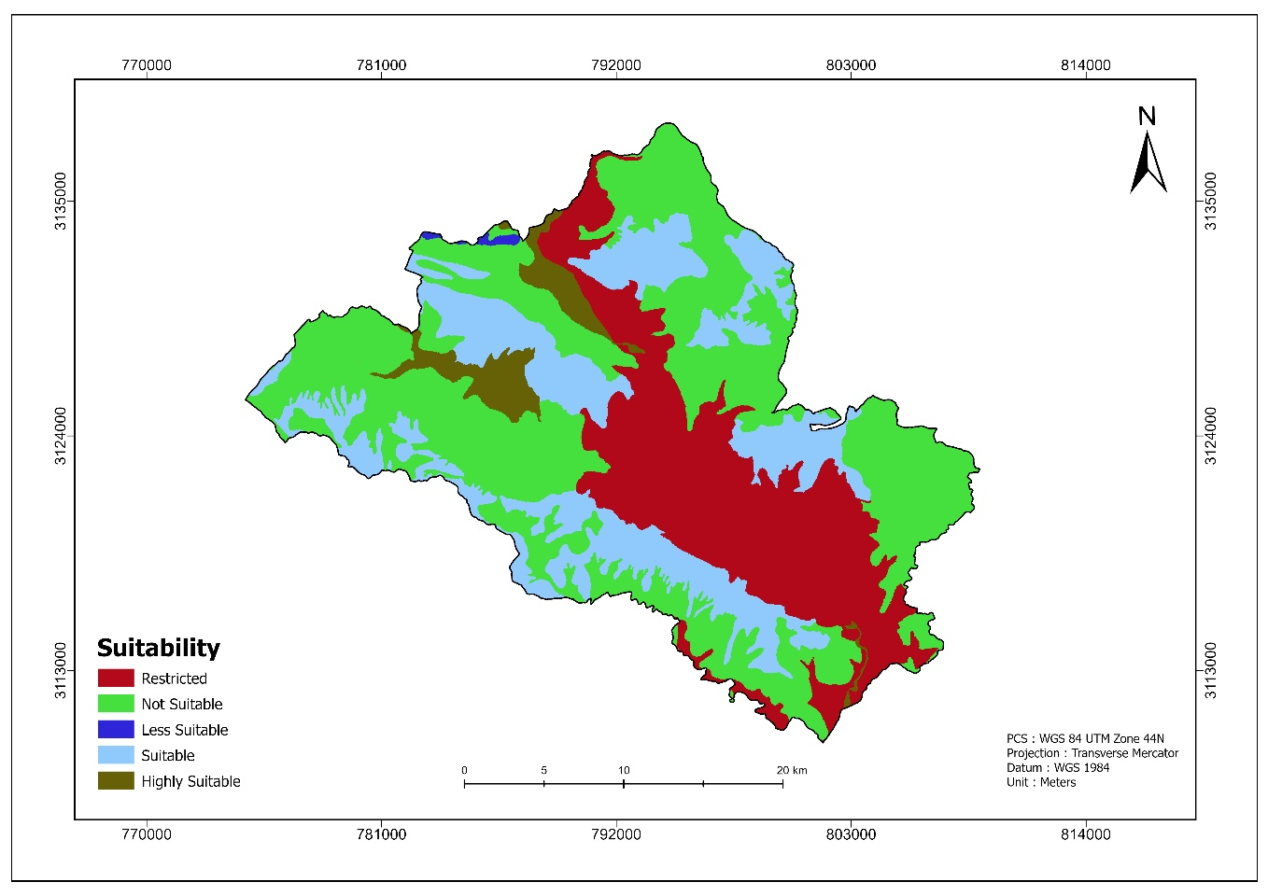
Figure 7 Suitability of Soil Type to optimize landfill siting in Pokhara Metro-politan City, Nepal as of July 2025.
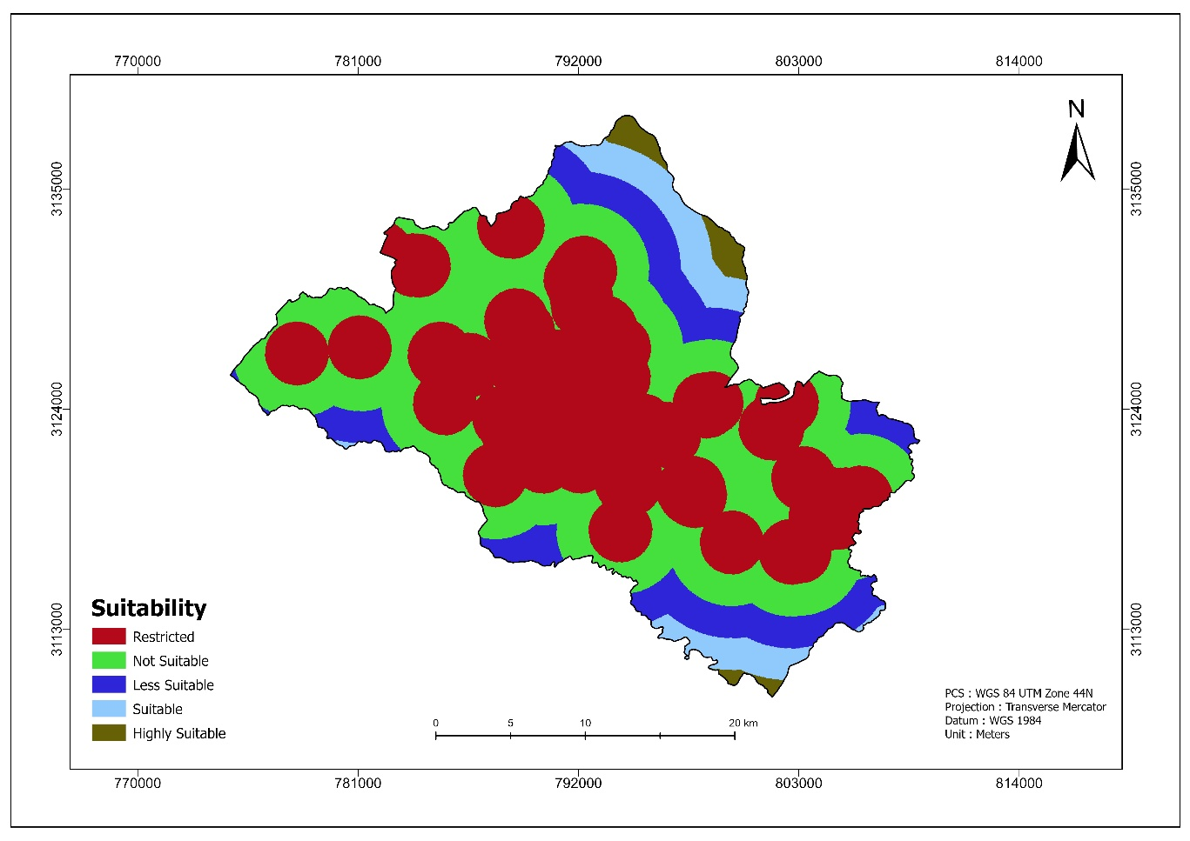
Figure 8 Suitability of Tourism Impact to optimize landfill siting in Pokhara Metropolitan City, Nepal as of July 2025.

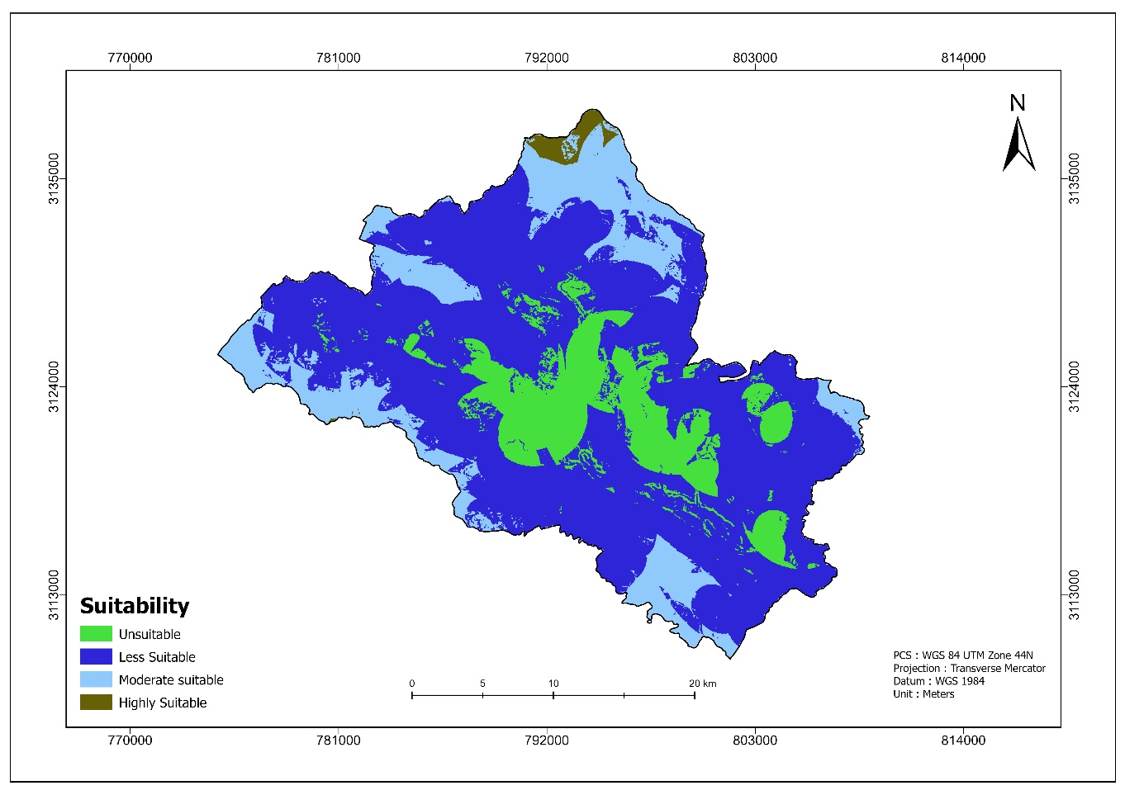
Figure 9 Suitability Map.
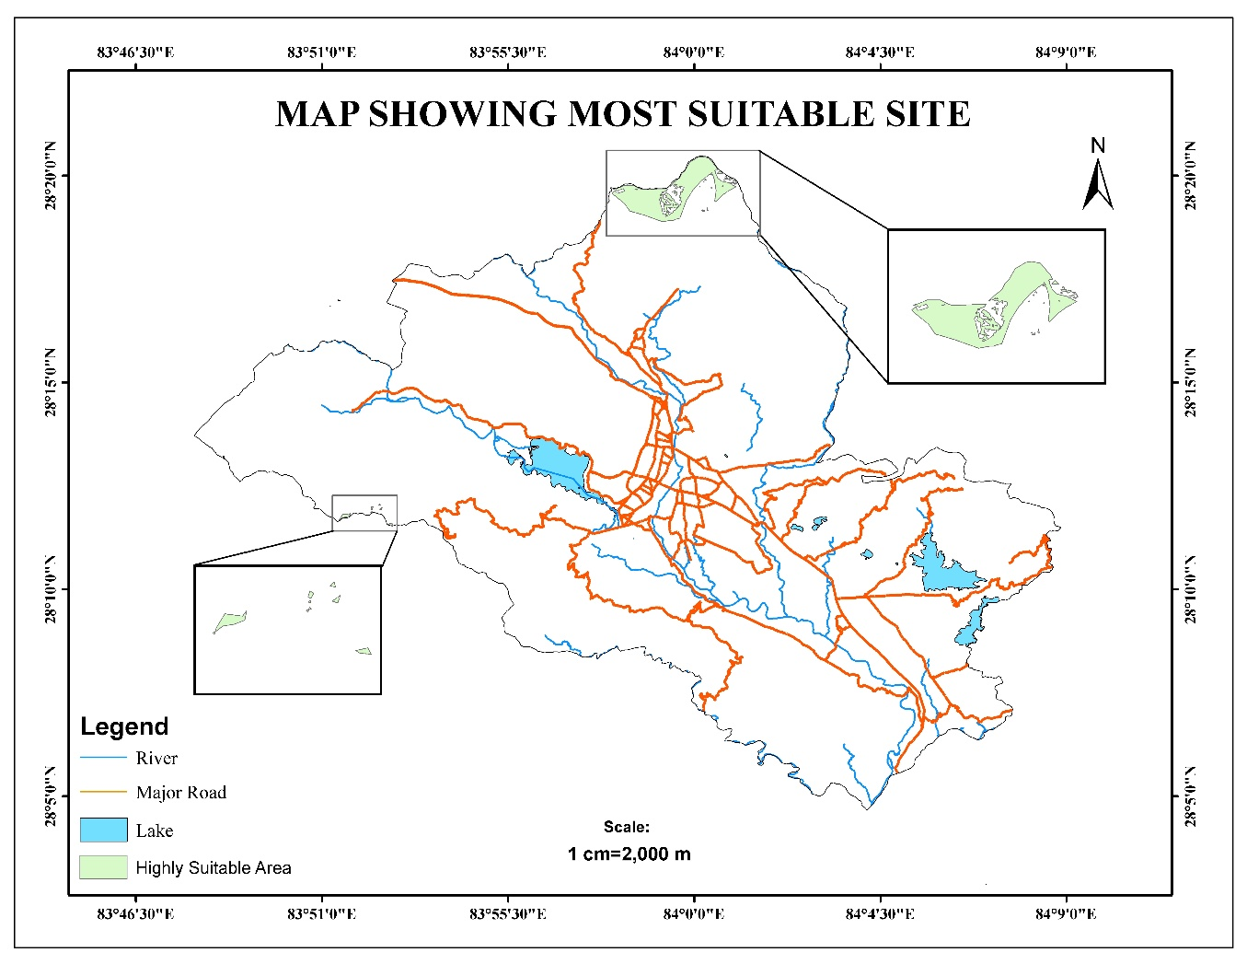
Figure 10 Map showing Most Suitable Site.
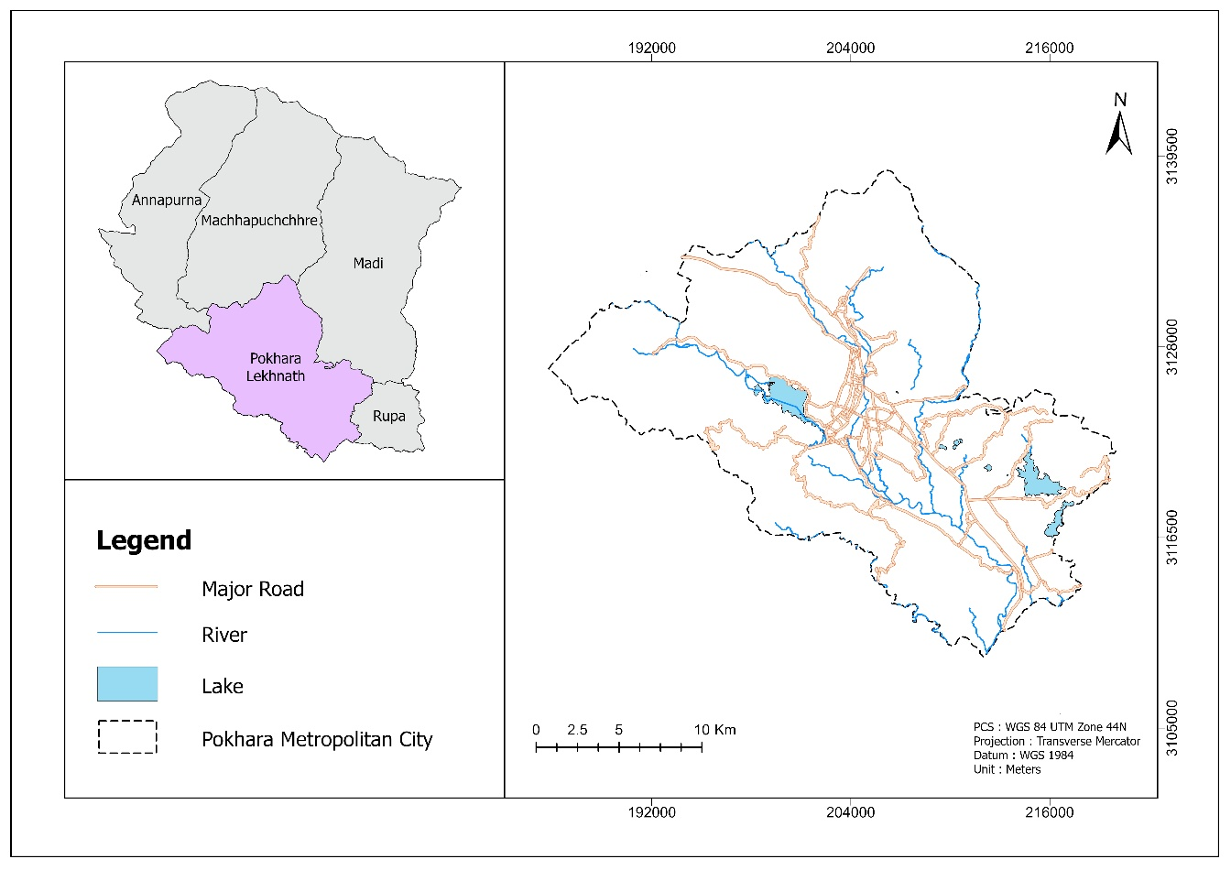
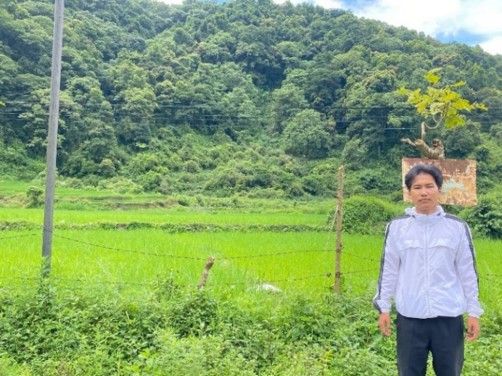
Figure 11 Map of the study area: Pokhara Metropolitan City - Nepal.
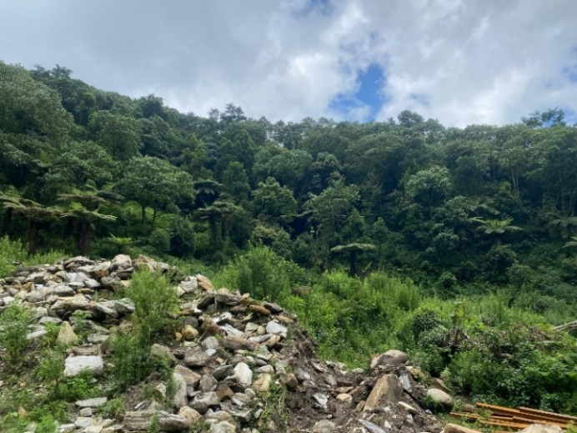
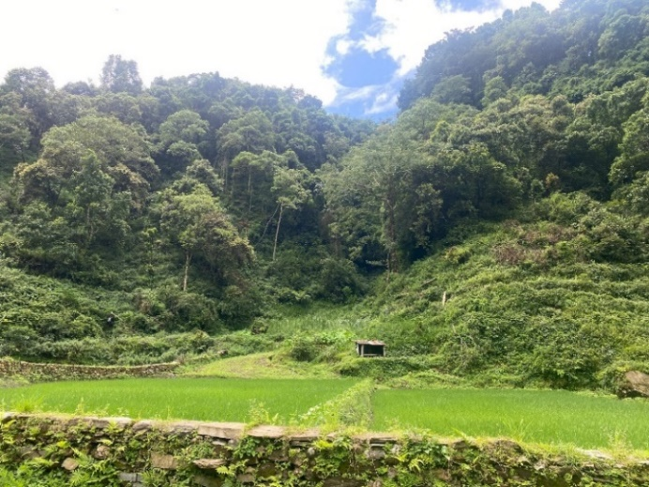
Figure 12 Photographs from the field verification

Table 1 Sources and types of digital data used in optimizing landfill siting in Pokhara Metropolitan City
Factors | Type | Source
Soil | Raster | http://www.isric.org
Lake | Vector | HOTOSM Export
Road | Vector | HOTOSM Export
River | Vector | HOTOSM Export
Slope | Raster | ASTER Global Digital Elevation Model-USGS
Settlement | Vector | HOTOSM Export
Tourism | Vector | HOTOSM Export
LULC | Raster | ICIMOD

Table 2 Pairwise Comparison matrix
Factors | Soil | Lake | Road | River | Slope | Settle | Tourism | LULC
Soil | 1 | 1/5 | 1/2 | 1/4 | 2 | 1/5 | 1/2 | 2
Lake | 5 | 1 | 3 | 1 | 3 | 4 | 3 | 5
Road | 2 | 1/3 | 1 | 1/3 | 2 | 1/3 | 1 | 2
River | 4 | 1 | 3 | 1 | 3 | 4 | 2 | 4
Slope | 1/2 | 1/3 | 1/2 | 1/3 | 1 | 1/3 | 1 | 2
Settle | 5 | 1/4 | 3 | 1/4 | 3 | 1 | 3 | 4
Tourism | 2 | 1/3 | 1 | 1/2 | 1 | 1/3 | 1 | 2
LULC | 1/2 | 1/5 | 1/2 | 1/4 | 1/2 | 1/4 | 1/2 | 1

Table 3 Weights of factors used in optimizing laandfill siting in Pokhara Metropolitan City
Factors | Weight (%)
Soils | 5.7
Lake | 26.1
Road | 8.7
River | 23.9
Slope | 6.5
Settlement | 16.9
Tourism | 8.4
LULC | 3.8

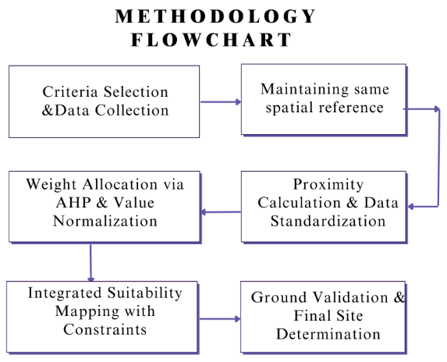
Figure 13 Methodology Flowcharts

